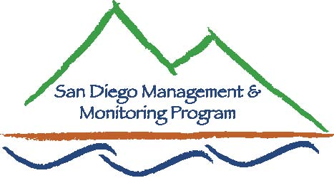

SDMMP Monitoring & Management Coordination Meeting
July 26, 2017, 9:30 am – 11:30 am
MEETING LOCATION CHANGE: We will be in the Conference Room on the 1st floor in the City of San Diego PUD building across the parking lot from the USGS offices at 4165 Spruance Rd, San Diego, CA 92101
Contact Info: Yvonne C. Moore, Administrator (evemoore99@gmail.com); Kris Preston, Ecologist (kpreston@usgs.gov); Emily Perkins, GIS Manager (eperkins@usgs.gov);, Sarah McCutcheon, Projects Manager (Sarah.McCutcheon@aecom.com), Brenda McMillan, Outreach Coordinator (Brenda.McMillan@aecom.com), Annabelle Bernabe, Data Entry/GIS Assistant (aebernabe@gmail.com), Frank Winter, Data Entry Assistant (fwinter@usgs.gov)

Agenda

- Introductions (9:30 - 9:35am)

- Announcements (9:35 – 9:50am)
  - SDMMP Updates
  - Others Updates

- Speaker (9:50 – 11:00am)
  - Heather Davis and Ed Ervin from the Back Country Land Trust will be giving a talk on the current projects at Long Protrero.

- Roundtable Discussion (11:00 – 11:25am)

- Closing Remarks and Future Meeting Topics (11:25-11:30am)

August - TBA
September - Coastal California Gnatcatcher news and updates Barbara Kus, USGS
November - ******NO MEETING******

Possible future topics:
- Coastal Cactus Wren habitat restoration
- San Diego’s Golden Eagle project
- Burrowing Owl burrow design

Our next monthly monitoring meeting will be held 9:30 a.m. – 11:30 a.m. on Wednesday,
August 23, 2017 at USGS

