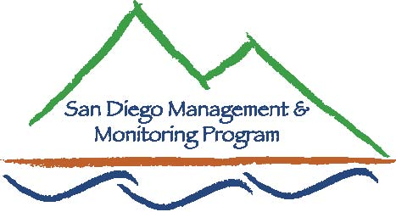

SDMMP Monitoring & Management Coordination Meeting
June 28, 2017, 9:30 am – 11:30 am
We will be in the Conference Room 103 at the USGS offices 4165 Spruance Rd, San Diego, CA 92101
Contact Info: Yvonne C. Moore, Administrator (evemoore99@gmail.com); Kris Preston, Ecologist (kpreston@usgs.gov); Emily Perkins, GIS Manager (eperkins@usgs.gov); Trish Smith, Coordination Support (trish_smith@tnc.org), Sarah McCutcheon, Coordination Support (Sarah.McCutcheon@aecom.com), Brenda McMillan, Outreach Coordinator (Brenda.McMillan@aecom.com), Annabelle Bernabe, Data Entry/GIS Assistant (aebernabe@gmail.com), Frank Winter, Coordination Support (fwinter@usgs.gov)

Agenda

- Introductions (9:30 - 9:35am)

- Announcements (9:35 – 9:50am)
  - SDMMP Updates
  - Others Updates and Announcements

- Speakers (9:50 – 11:00am)
- Markus Spiegelberg, Center for Natural Lands Management - Long-term rare plant monitoring data, restoration success, methods and results; looking at trends in abundance vs. rainfall/habitat conditions
  - Yvonne Moore and Kris Preston, SDMMP – Regional Land Manager grant opportunities and more!

- Roundtable Discussion (11:15 – 11:25am) Time Permitting: Volunteers part 2:
- Closing Remarks and Future Meeting Topics (11:25-11:30am)

Upcoming Speakers:
July - The Back Country Land Trust Updates and Current Projects at Long Protrero, Heather Davis, Scott McMillan and Ed Ervin
August - TBD
September – Coastal California Gnatcatcher news and updates Barbara Kus, USGS
October – Christina Shaeffer - Oceanside Preserve System introduction and updates

Possible future topics:
- Marine Corp Base Camp Pendleton: latest news and current projects
- San Diego’s Golden Eagle project

Our next monthly monitoring meeting will be held 9:30 a.m. – 11:30 a.m. on Wednesday,
July 26, 2017 at USGS

