San Diego Association of Governments
Ocean Beach Estuary Enhancement Project
The San Diego River Park Foundation (SDRPF)
Quarterly Progress Report
Reporting Period: 10/01/23 – 12/31/23
Submission Date: 1/21/24
SANDAG Contract Number: S1125510

Quarterly Status Report Overview
PLEASE DO NOT CHANGE OR ALTER THE FORMATTING OF THIS DOCUMENT! SANDAG has developed a standardized grant monitoring and tracking program for the Environmental Mitigation Program (EMP) Land Management Grant Program. The purpose is to collect information on individual projects and the grant program as a whole for reporting to the Regional Habitat Conservation Taskforce, SANDAG Policy Advisory Committees, and the SANDAG Board of Directors. SANDAG monitors grantees through invoices, progress reports, performance measures, and designated photograph points. These standardized reporting templates and instructions for submittal are included below.

Work Performed this Period:

Task 1 - Invasive Removal and Habitat Restoration
Because most of the invasive removal portion of our restoration project requires a Coastal Development Permit that has not yet been awarded, we continue to focus on planning and securing the permit (see Task 5 discussion of permit status). The SDRPF staff continues to conduct internal meetings and collaborate with project partners to expedite permit proceedings, strategize for the pre-permit phase, and ensure preparedness for the prompt commencement of work once the permits are obtained.

Additionally, SDRPF interns and staff updated the invasive and native plant handout and the species of special concern handout. Through site visits in quarter four, more invasive and native plants have been added to the handout to better represent the flora present across the different habitats in the project area. Some of the invasive species that have been added to this educational piece include crystalline ice plant, wall barley, small melilot, and cheeseweed, while some native plant species added include evening primrose, seacliff wild buckwheat, shore grass, and marsh jaumea. A first draft of a project brochure was also created, which will facilitate volunteer recruitment, training and orientation.

5.2% complete.

Task 2 - Access Control
No field work has been completed for this task while project partners await permits to begin installing the access control fencing.

During a site visit this quarter, staff and volunteers did record tire tracks within the project area that indicated that unfortunately, a passenger vehicle of some kind had illegally driven into the habitat area, damaging an area that had recorded occurrences of Nuttall’s acmispon and coast wooly heads. This kind of damage will be much more difficult after the access control improvements this project will include, and illustrates the need for improved access control to prevent damage to these sensitive habitats. The illegal access was reported to City of San Diego biologists and Ranger staff. Photos of the damage are included here as Photos 1-2.

1.1% complete.

Task 3 - Community Engagement, Education and Outreach
Community engagement staff continued planning for outreach events and met with representatives of organizations in the Ocean Beach/Point Loma community to work on establishing a visible, long-term presence at the River Mouth. Staff posted flyers in local businesses and public posting boards and met with organizations such as San Diego Audubon Society, Friends of Point Loma Native Plant Garden, and Coastal Sage Gardening.

SDRPF staff hosted an interpretive event on December 16 that offered a structured way for the community to explore the area and how the project would protect the habitat. A volunteer leader provided guided nature walks to give context to the area by highlighting the biodiversity, sensitivity of the habitat, and opportunities for stewardship. Staff set up an ornithology exhibit as part of this outreach event which displayed taxidermized brown pelican, killdeer, snowy egret, dunlin, and other specimens (borrowed from the San Diego Natural History Museum) as well as interpretive flyers to allow the community to get up close with the fauna that rely on the habitats that this project will help protect. Two outreach volunteers helped support the event and assisted staff in connecting with 25 community members through tours.
Outreach partners from the San Diego Audubon Society held one docent program per week at the River Mouth in October-December. They are still preparing to start a Bark Ranger program, which will kick off early in the 2024 calendar year. In early 2024, they will summarize and share the community engagement and species disturbance results of our year of docent programs at the River Mouth. Pictures from this outreach effort are included as Photos 3 - 5.

7.4% complete.

Task 4 – Monitoring
This quarter, both SDRPF and SDAS staff coordinated and planned monitoring activities to engage community members in early 2024. Two community science BioBlitz events have been planned to involve volunteers within the project area and to document the flora and fauna present across different habitat types. The first scheduled event will be held on February 2nd to align with World Wetlands Day, while the second event will take place on April 26th for the City Nature Challenge—an international effort for people to find and document plants and wildlife in cities across the globe.

SDRPF staff are still awaiting the 2023 report from the salt marsh bird's-beak and Nuttall's acmispon survey conducted in the project area in partnership with the City earlier this year, and will include it in a future report once received. To gain a better understanding of the general state of these two rare plant species, data for both rare plants were downloaded from SDMMP's ‘Rare Plant Inspect and Manage Monitoring 2014-2026’ program for review to inform future work. Once the 2023 survey data is available, maps will be created and added to the previous years' database.

Our partners at San Diego Audubon Society have scheduled two Ridgway’s rail surveys to take place in the first quarter of 2024: a King Tide survey of the River Mouth on January 11th, and a survey with the regional coordinator of Ridgway’s Rail monitoring, Dick Zembal, mid-March when the rails start calling. The connections being made with the public and volunteer docents will help the project to add and benefit from volunteers in these surveys next quarter.

10.3% complete

Task 5 - Administration
Project administration this quarter included submitting our second invoice and progress report, troubleshooting the SDMMP Project Page, and working with SANDAG staff and labor compliance to resolve an account issue with the subcontractor. Staff coordinated with the City of San Diego to document and report on their in-kind matching funds. Project admin also included other correspondence with partners and SANDAG, updating budgets and coordinating timesheets and reports both internally and from partner organizations.

In addition, staff continued to meet with the City of San Diego and SDAS at least monthly about the permits to enable this project. As previously reported, the invasive removal, fencing and some signage will require a Coastal Development Permit from the California Coastal Commission. The City of San Diego (as the landowner) is the lead for this application, and SDAS and SDRPF named partners in completing the work.

Responses have been submitted to the Army Corps of Engineers for review, and project partners are waiting for confirmation that the responses have are satisfactory and ready to move the next step in the process.

14.1% complete.

Provide the exact work start date, a description of the work completed under each task, and percent complete. Add additional tasks as necessary

Work Anticipated Next Period
This does not need to be task specific but should include a short paragraph or bullet point list of activities anticipated for next quarter.

We are hopeful that the Site Development Permit from the City of San Diego will be awarded this quarter, and will work toward this. As we have been advised by the Coastal Commission, once this is complete, we will then promptly get the proposal back on the agenda for the Coastal Commission to secure the Coastal Development Permit.

In addition, we expect that winter weather will necessitate invasive removal work parties in the first quarter of 2024. Until the permit is awarded, this work will be limited to the City of San Diego’s current maintenance area around existing trails in the project area, but will be expanded into the habitat area as soon as allowable.

Community outreach and volunteer will continue with the monitoring and educational events planned. Staff will work with City of San Diego Natural Resources staff to plan for rare plant monitoring during the appropriate windows in spring 2024, and San Diego Audubon staff will complete bird monitoring.

Issues to Note
Please provide a brief description of any issue(s) encountered during the reporting period and any steps taken to address the issue(s).

As discussed in the Task 5 report above, the permitting for the project is taking longer than anticipated. We are working with the City of San Diego (the permit applicant) to resolve the remaining questions to submit the final permit package for review and award.

Photographs & Figures
Photographs and figures are invaluable! Please include photos in the Quarterly Progress Reports and any figures (if applicable). Both photos and figures may be included throughout the document under corresponding tasks or at the end following the Issues to Note section. Photographs taken at the same place or photographic points (photo-points) can assist SANDAG staff in tracking the project’s progress over time.
It is required that Photographs include:
- A before and after comparison sequence from the start to the completion of the project for photo points.
- A brief description of the corresponding tasks, date, and activity in the photograph.
- A copy of each photograph included in the report submitted in a .jpeg or .png file format.
It is required that Figures include:
- A caption with a brief description.

Task 2: Access Control
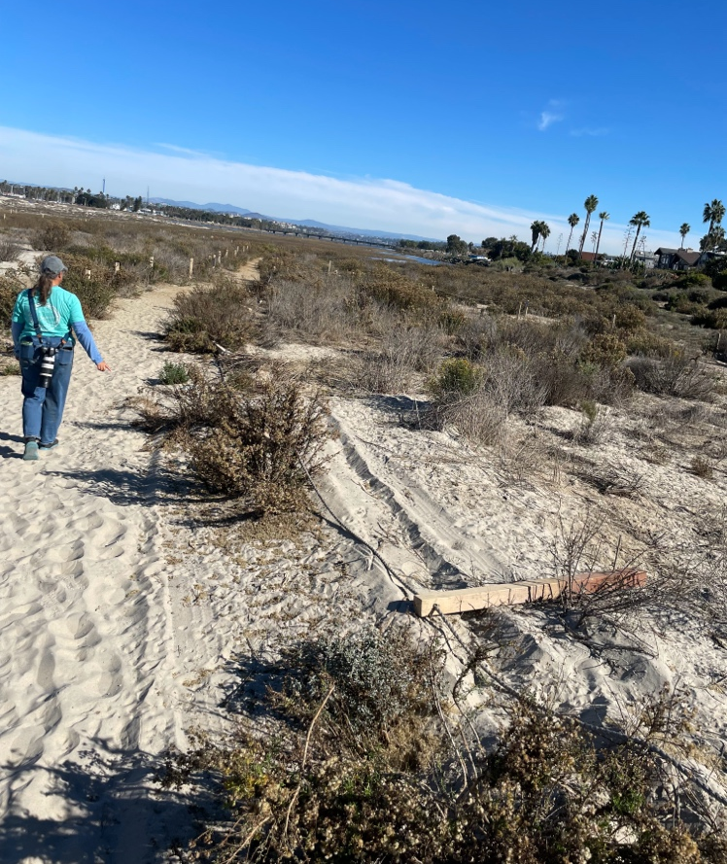
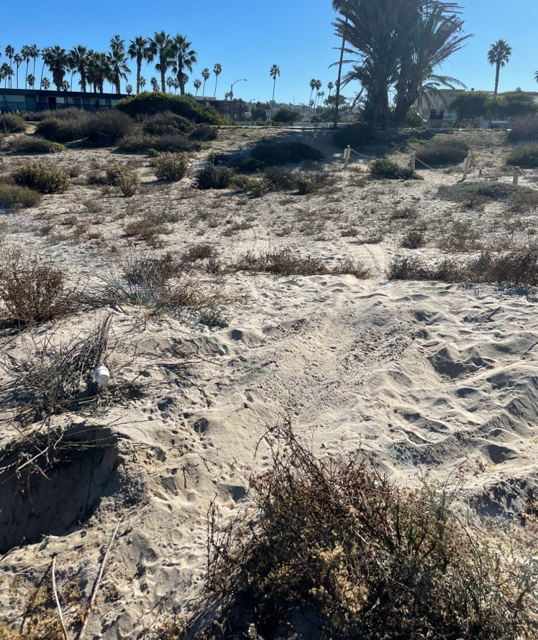
Photos 1 and 2: Damage from illegal vehicle access in the dunes.

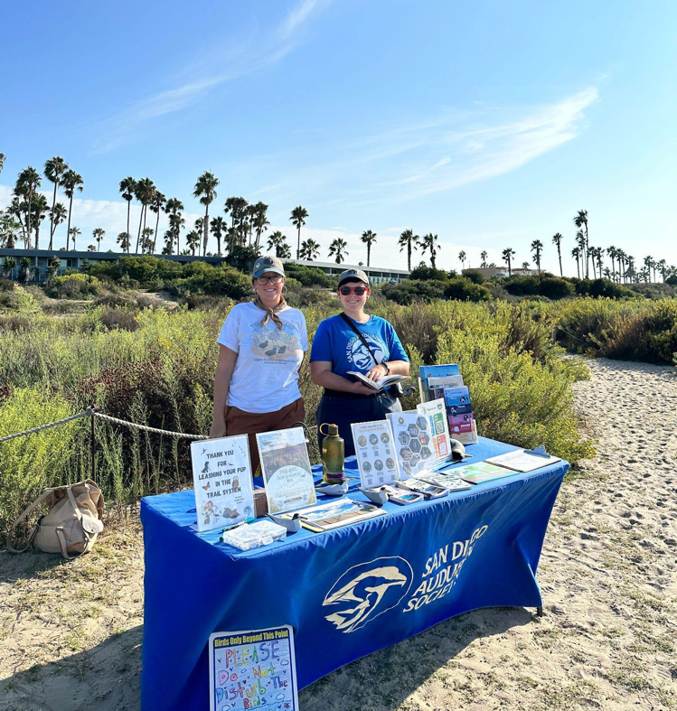
Task 3: Community Engagement, Education, and Outreach
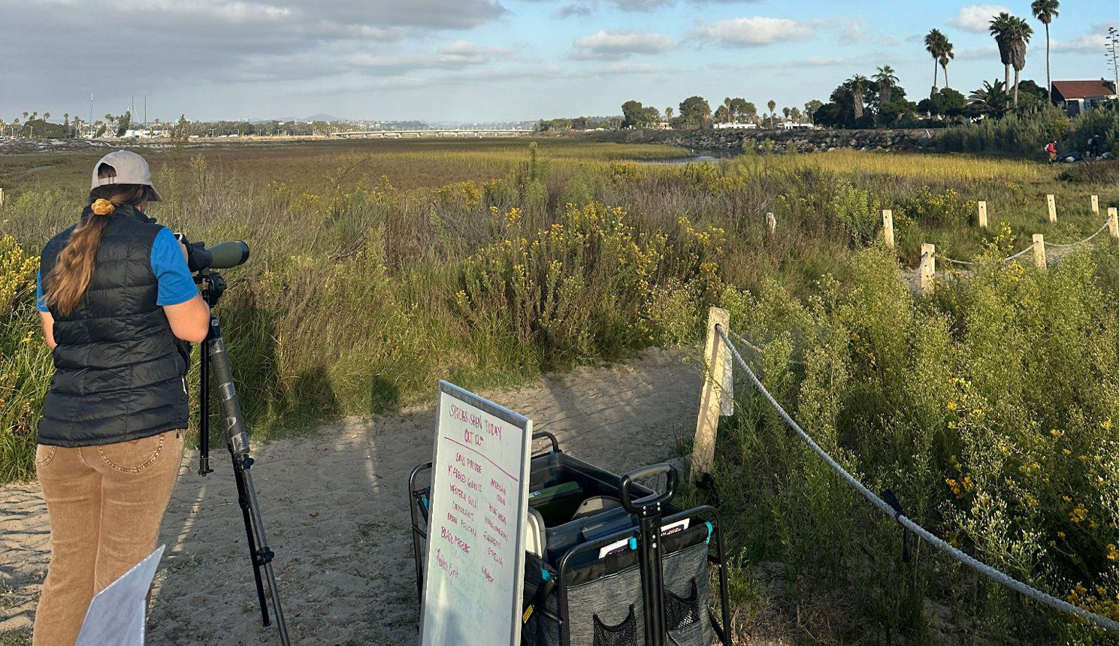
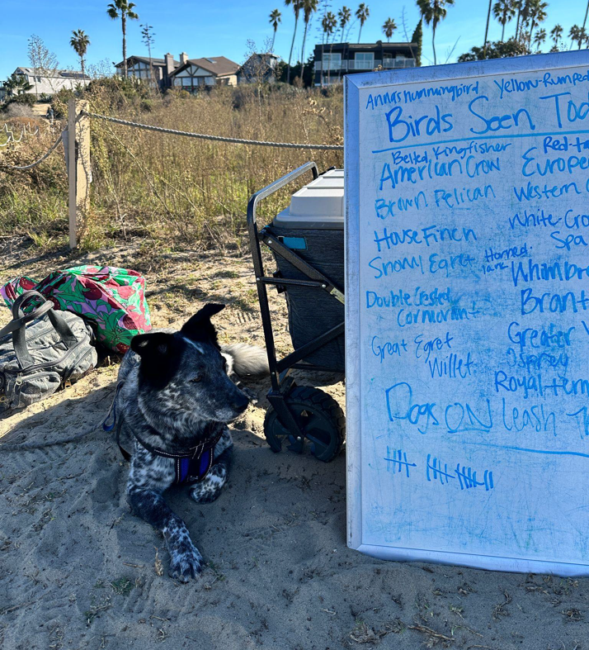
Photo 3 and 4: San Diego Audubon Society docent outreach booth set-up at project site

SDMMP Project Page
To receive reimbursement for work conducted within the quarter, submission of Quarterly Progress, Annual, and Final Reports must be added to your project’s Project Page on the SDMMP website. Add any necessary photographs to the photo carousal and fill out the photograph information. Please contact Sarah McCutcheon (smccutcheon@usgs.gov) or Emily Perkins (eperkins@usgs.gov) if you are having trouble accessing or editing your project page.

Project Performance Measures Instructions
SANDAG will utilize the SANDAG Performance Measures to document compliance with the Project. Grantee’s performance will be measured against the Performance Measures (Exhibit D) during the term of the project. More details on Performance Measures and Grant Recovery Plans are outlined in the Grant Agreements.
To access the Project Performance Measures Excel Spreadsheet:
- Simply double-click on the Excel icon located under the Project Performance Measures section.
  - An excel sheet will open, please fill out and then click save.
- Once the Excel spreadsheet is saved, please exit Excel and the spreadsheet will automatically update the icon in the Quarterly Progress Report Word document.
When opening the document with the Project Performance Measures Excel Spreadsheet:
- When you first open the Quarterly Progress Report Template, a warning message will open (image of the warning message below)
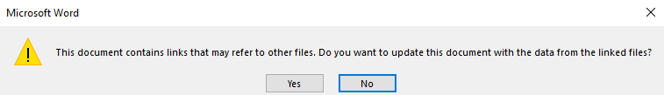
  - Click Yes to update the links in the document.

Performance Measures
Please include the Project’s Performance Measures for each Quarterly Invoice and Progress Report in order to receive reimbursement.

