San Diego Association of Governments
Quarry Creek Preserve Fencing Project
San Diego Habitat Conservancy
Final Report
Project Period: April 21, 2023 –December 31, 2023
Submission Date: January XX, 2024
SANDAG Contract Number: S1125500

Executive Summary
The goal of the Quarry Creek Fencing Project (Project) was to reduce human use within the Diegan coastal sage scrub and southern riparian forest habitat within San Diego Habitat Conservancy’s (SDHC) 95.92-acre Quarry Creek Preserve (Preserve). The objectives were to (1) install 721 linear feet of fencing to prevent human trespassing, and (2) conduct trash removal within a 5.28-acre target area of the Preserve. SDHC completed Objective 1 by first identifying priority fencing areas based on high trespass locations without existing fencing. SDHC’s Habitat Manager (HM) coordinated with a fencing contractor, Scott Fence, and met with them onsite to discuss and mark the placement of the wrought iron fencing and gates. Though not part of the EMP Land Management Grant, prior to fence installation, the HM contracted Black Sage Environmental, to conduct trespasser removal with the Oceanside Police Department to ensure no individuals would be contained within the area once the fencing was complete. The installation of the six-foot tall 721 linear feet of wrought iron fencing started on June 12, 2023 and was completed on July 13, 2023.
Objective 2 was completed in April 2023. The work was completed by coordinating with partner organizations, Preserve Calavera, I Love a Clean San Diego, and the City of Oceanside. The event was advertised by all partners involved and 101 volunteers and 5,500 pounds of trash were removed within the 5.28-acre target area. An additional trash cleanup was conducted in September 2023, removing 4,000 pounds of trash, going above and beyond the scope of work.
One of the positive outcomes from this project, is it inspired additional partners such as Preserve Calavera, RG Real Estate, and Albertson’s Grocery Store to contribute to a fencing fund to help with fencing for other areas of trespass and to pay for ongoing fence maintenance. The EMP grant helped bolster the support, leading to an additional $30,000 in funding for the Preserve ($5,000.00 from Preserve Calavera, $15,000.00 from Albertson’s Grocery Store, and $10,000.00 from RG Real Estate).
The installation of the fencing has resulted in a significant decrease in trespassing and encampments. The fencing has been damaged three times since installation and has required repairs. It is expected that the fence will need continual maintenance over the long-term.

Final Report Overview
PLEASE DO NOT CHANGE OR ALTER THE FORMATTING OF THIS DOCUMENT! SANDAG has developed a standardized grant monitoring and tracking program for the Environmental Mitigation Program (EMP) Land Management Grant Program. The purpose is to collect information on individual projects and the grant program as a whole for reporting to the Regional Habitat Conservation Taskforce, SANDAG policy advisory committees, and the SANDAG Board of Directors. SANDAG monitors grantees through invoices, progress reports, performance measures, and designated photograph points. These standardized reporting templates and instructions for submittal are included below.

Table of Contents Instructions
To use the automatic Table of Contents:
- First add all of your data to the Project Tasks, Conclusions, Geographic Information System (GIS), Photographs, Figures, and Appendices sections.
- When you are finished adding, removing, or editing Work Performed by Task, Conclusions, GIS, Photographs, Figures, and Appendices sections, simply click once on the Table of Contents.
- Then click Update the Table in the upper left-hand corner of the Table.
  - A window will open for you to choose to update just the page numbers or the entire table, choose to update the entire table.
- The Table will automatically update the headers and page numbers from the information you inputted in the rest of the report.
*Each header will be hyperlinked to the corresponding page for easier access.
Please do not manually update the Table of Contents. It will automatically update when you add, remove, or edit the Work Performed by Task templates below on page 4 and click update the entire table on the Table of Contents.

Table of Contents
Executive Summary 1
Project Background 4
Project Goals 4
Work Performed by Task 5
Task 1- Install Wrought Iron Fencing 5
Task 2- Trash Removal 6
Task 3- Reports 6
Task 4- Administrative 6
Conclusions 16
Geographical Information Systems Data 16
SDMMP Project Page 17
Performance Measures 17
Appendices 17
State of Preserve Monitoring 18

Project Background
Provide an in-depth background on the project including:
- Project Setting: project site size, preserve name, preserve location.
- The need and how the project pertains to the goals and objectives specified in the MSP Roadmap (https://sdmmp.com/portal.php; https://sdmmp.com/tracker.php).
- Project location and site description.
- How does the project anticipate addressing the issue(s) identified (methods/approach to be used)?
*Use sub-headings as necessary to organize this section.

The Quarry Creek Fencing Project was completed at the 95.92-acre Quarry Creek Preserve (Preserve) in Oceanside, California. The Preserve is in San Diego County's Multiple Habitat Conservation Program, and part of a larger network of preserves in the area, including the California Department of Fish and Wildlife (CDFW) Buena Vista Creek Ecological Reserve, Calavera Hills Preserve, and Robertson Ranch Conservation Area. Wildlife species detected on the Preserve include the coastal California gnatcatcher (Polioptila californica californica; CAGN), least Bell’s vireo (Vireo bellii pusillus; LBVI), white-tailed kite (Elanus leucurus; WTKI), yellow warbler (Setophaga petechia), and yellow-breasted chat (Icteria virens). The Management and Monitoring Strategic Plan for Conserved Lands in Western San Diego County: A Strategic Habitat Conservation Roadmap (MSP Roadmap) classifies LBVI as a Significant Occurrence at risk of loss (SO) species and has been observed within the proposed work area habitat regularly. CAGN is classified as a Species more stable but still requires species-specific management to persist in MSP Area (SS). Human use was resulting in the loss of ecological integrity for DCSS habitat within the Preserve and is one of the highest-level threats to MSP priority species LBVI and CAGN.
SDHC addressed the issue of human use by installing 801 linear feet of wrought iron fencing and conducting trash removal events.

Project Goals
What are the objectives of the project/expected results? Were the project goals achieved? If not, explain why the project goals were not achieved or partially achieved.

The goal of the Quarry Creek Fencing Project (Project) was to reduce human use within the Diegan coastal sage scrub and southern riparian forest habitat within San Diego Habitat Conservancy’s (SDHC) 95.92-acre Quarry Creek Preserve (Preserve). The objectives were to (1) install 721 linear feet of fencing to prevent human trespassing, and (2) conduct trash removal within a 5.28-acre target area of the Preserve. SDHC exceeded the project goals by installing 801 linear feet of fencing with two gates and conducting two trash cleanup events.

Work Performed by Task
Provide exact start date(s), Provide in detail the work completed for each task during the course of the entire project, any issues encountered during task completion and steps taken to address the issue(s), whether the task was completed according to the original scope, whether the task came in at budget, and any results for the individual task. Include your assessment per the Performance Measures outlined. Include additional work that may be needed in the future to maintain the results/condition achieved if applicable.

Task 1- Install Wrought Iron Fencing
Budget: $66,151.60
Spent: $73,726.86
Match for Task: None

The goal of this task was to install 721 linear feet of fencing with two gates to prevent human trespassing. SDHC exceeded this goal by installing 801 linear feet of fencing and two gates. Though not part of the EMP Land Management Grant, SDHC hired a contractor, Black Sage Environmental, to conduct trespasser removal with the Oceanside Police Department to ensure no individuals would be contained within the area once the fencing was complete. Black Sage Environmental conducted site visits and trespasser removal on June 4, 12, and 25, 2023.
Prior to the start of fence installation and outside of the EMP Land Management Grant, the HM and volunteers prepared the work area by trimming vegetation along the fence layout. Scott Fence began installation of the wrought iron fence on June 12, 2023. This included the installation of gauge posts with concrete footings, gauge rails, gauge pickets, fencing panels, and two gates. Scott Fence completed installation of the fencing and gates on July 13, 2023.
Since installation, SDHC has noticed a significant decrease in trespassing, though there have been incidents of vandalism requiring fence repair. It is apparent that regular fence repair will be required in perpetuity. SDHC has private funds allocated for fence maintenance and repair.
The Grant Agreement for Task 1 was originally a total of $66,151.60. Due to an increase in materials and labor from when the proposal was submitted to the notice-to-proceed, SDHC reallocated funds from Task 2. Trash Removal. The amount for Task 1 was increased to $73,726.86. There was a less than 10% informal budget reallocation, and an informal budget amendment was approved and applied by SANDAG staff.

Task 2- Trash Removal
Budget: $7,575.26 (from grant agreement)
Spent: $0
Match for Task: $1,552.50
The goal for this task was to conduct a one-day trash removal event, removing 90% of existing debris within a 5.28-acre target area of the Preserve. The trash cleanup occurred on April 22, 2023. The work was completed by 101 volunteers and 5,500 pounds of trash were removed within the 5.28-acre target area. Partners involved in the cleanup included Preserve Calavera, I Love a Clean San Diego, and the City of Oceanside. Additionally, the HM coordinated with the City of Oceanside’s Homeless Outreach Team to perform trash removal in June and July. The HM led an additional trash cleanup on September 23, 2023, with 100 volunteers removing 4,000 pounds of trash, going above and beyond the scope of work.
The funds for this task were reallocated to Task 1. Initially, SDHC was going to hire contractors to contribute to the cleanup efforts but SDHC was able to meet the performance criteria for Task 2 by utilizing volunteers and matching funds.

Task 3- Reports
Budget: $ 2,780.00 (from grant agreement)
Spent: $2,780.00
Match for Task: None
A quarterly progress report and invoice for the April 1-June 30, 2023 reporting period was prepared and submitted on July 19, 2023. The quarterly progress report and invoice for the July 1-September 30, 2023 was prepared and submitted on October 20, 2023. The SDMMP website project page was updated in October 2023 and January 2024. The final report will be submitted on January 22, 2024.

Task 4- Administrative
Budget: $ 3,460.00 (from grant agreement)
Spent: $ 3,460.00
Match for Task: None
Task 4 began on April 21, 2023 when SDHC received the Notice-to-Proceed. Activities under this task included project set up, coordinating with contractors, and meeting with SANDAG. SDHC met with SANDAG staff at Quarry Creek on December 1, 2023 to view the fencing project and discuss the performance indicators.

Photographs & Figures

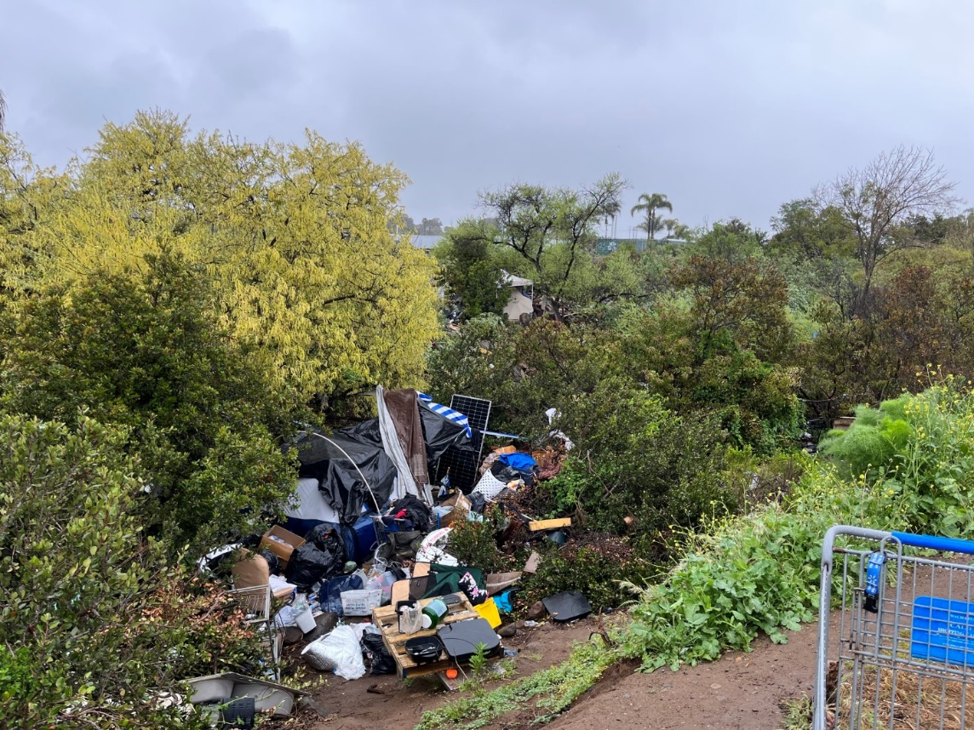
Photo 1. Trash at Quarry Creek Preserve, Before Trash Cleanup and Fence Installation (April 13, 2023)
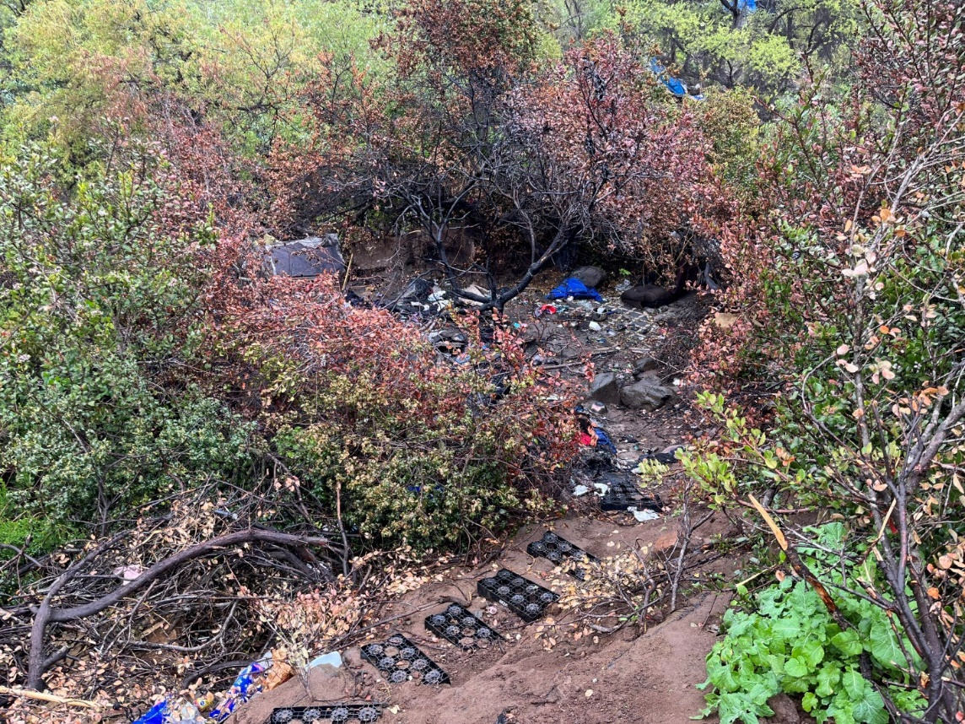
Photo 2. Trash at Quarry Creek Preserve, Before Trash Cleanup and Fence Installation (April 13, 2023)
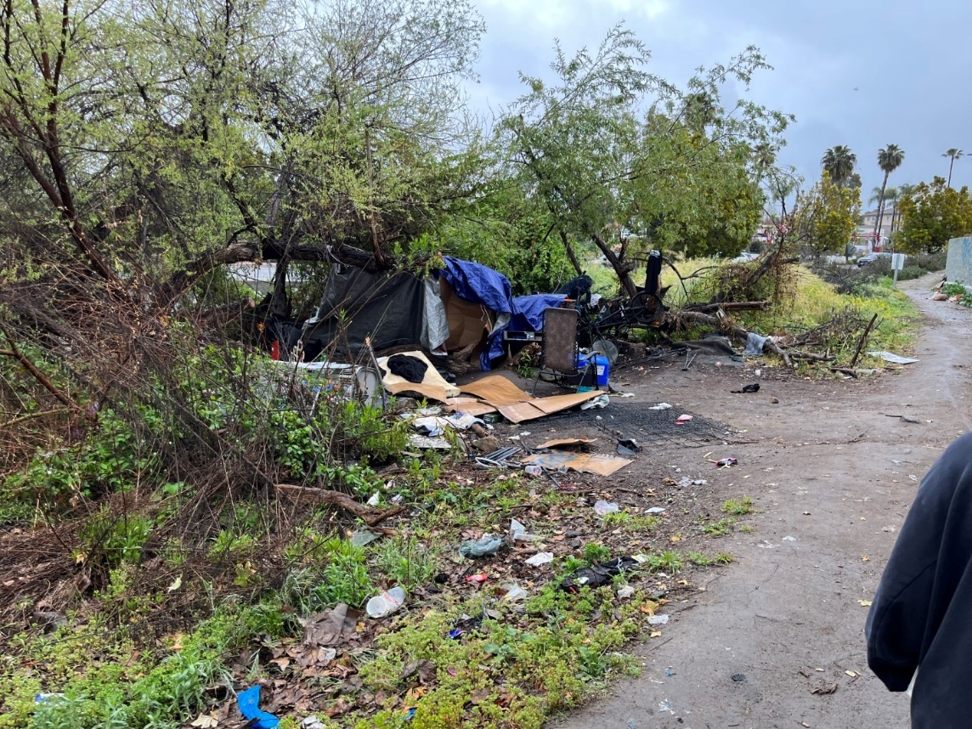
Photo 3. Trash and Encampments at Quarry Creek Preserve, Before Trash Cleanup and Fence Installation (April 13, 2023)
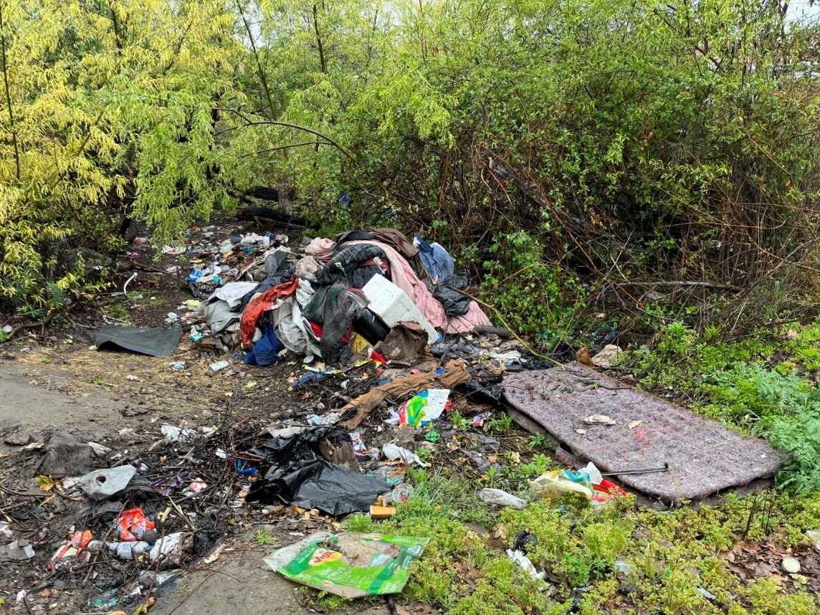
Photo 4. Trash Piles at Quarry Creek Preserve, Before Trash Cleanup and Fence Installation (April 13, 2023)

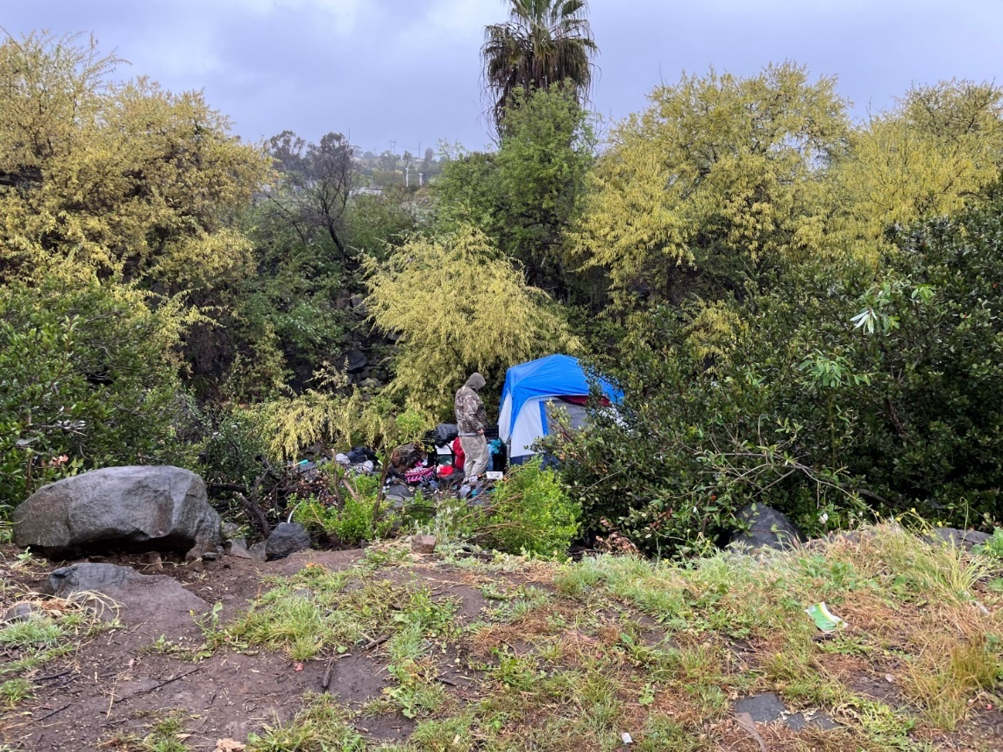
Photo 5. Quarry Creek Preserve, Encampments on Site Before Trash Cleanup and Fence Installation (April 13, 2023)
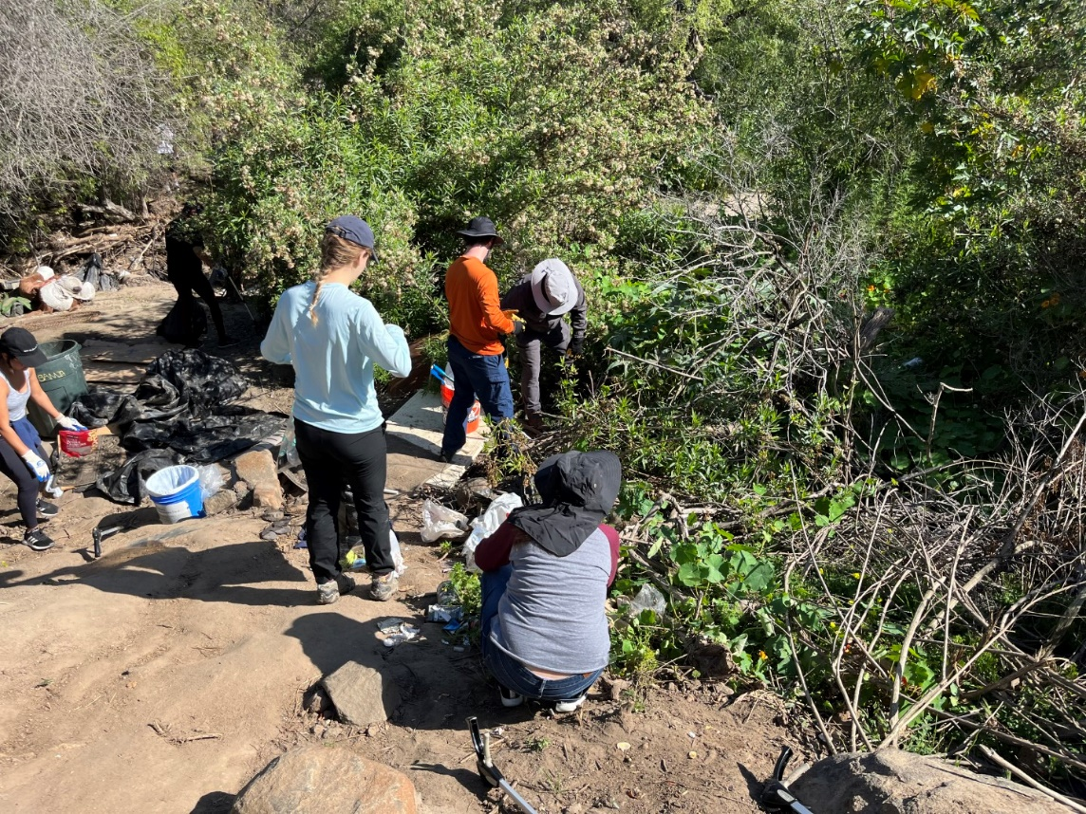
Photo 6. Volunteers picking up trash in the Preserve (April 22, 2023)
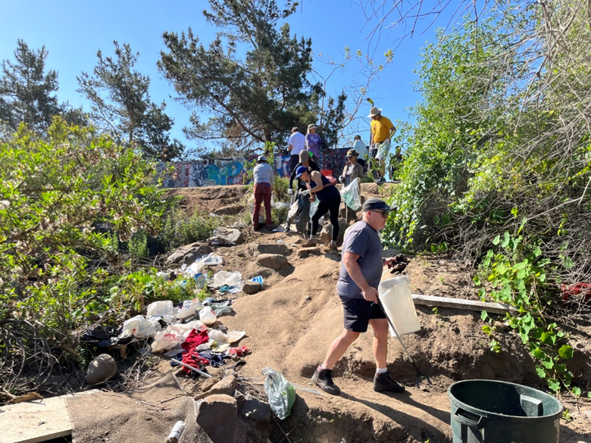
Photo 7. Volunteers picking up trash at the Preserve Trash Cleanup event (April 22, 2023)

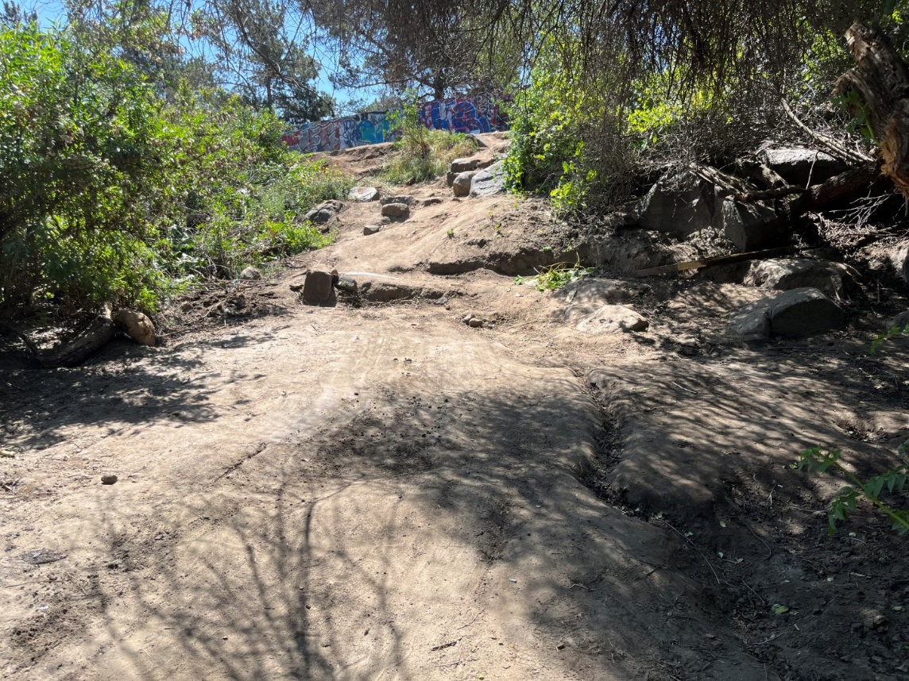
Photo 8. Quarry Creek Preserve, After Trash Cleanup (April 22, 2023)

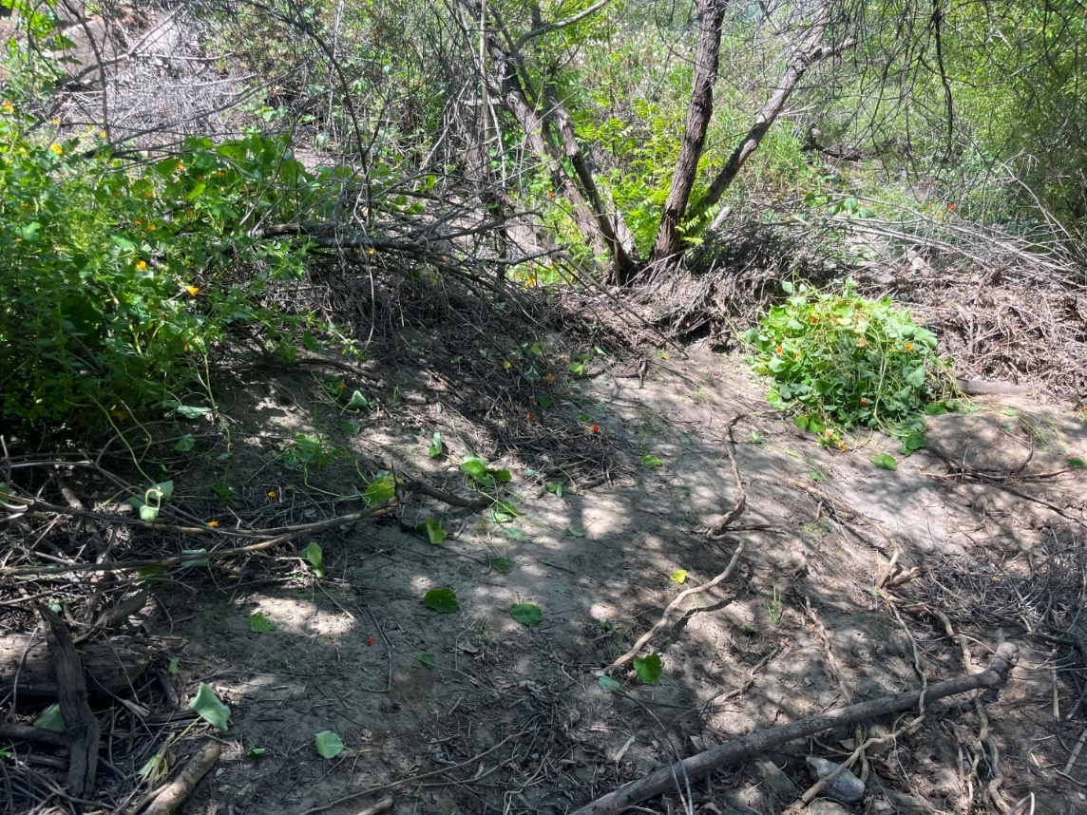
Photo 9. Quarry Creek Preserve, After Trash Cleanup (April 22, 2023)

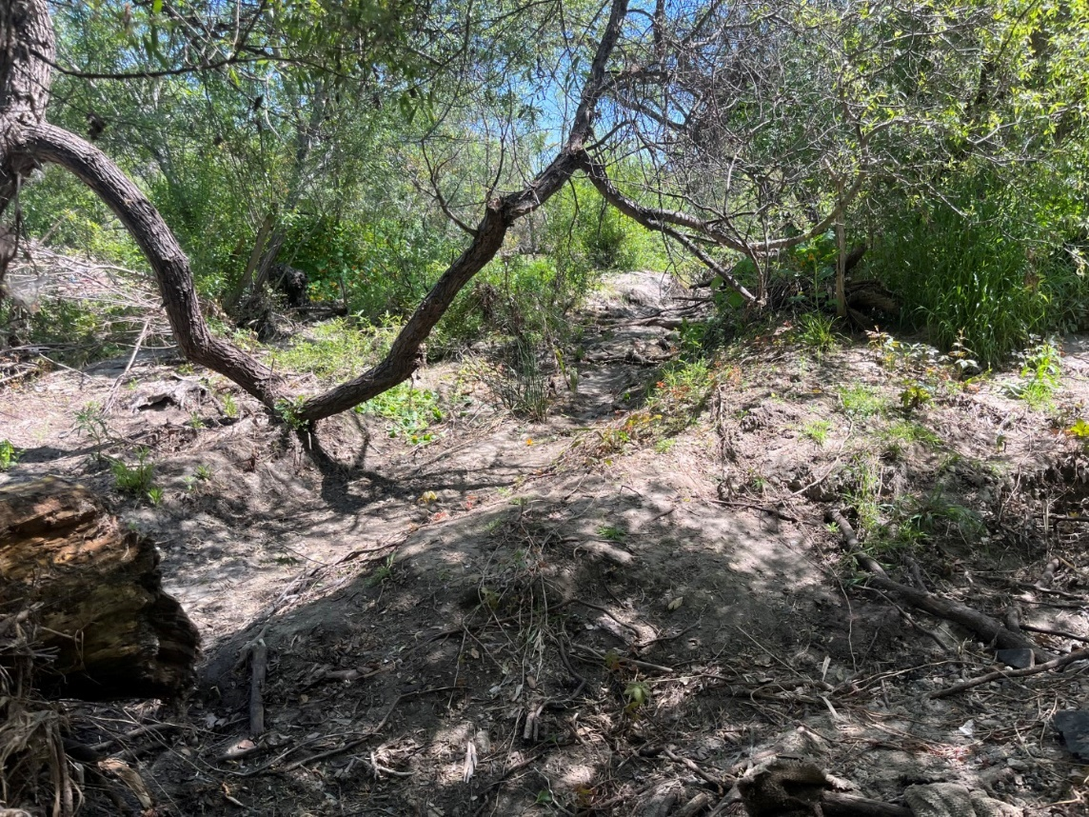
Photo 10. Quarry Creek Preserve, After Trash Cleanup (April 22, 2023)

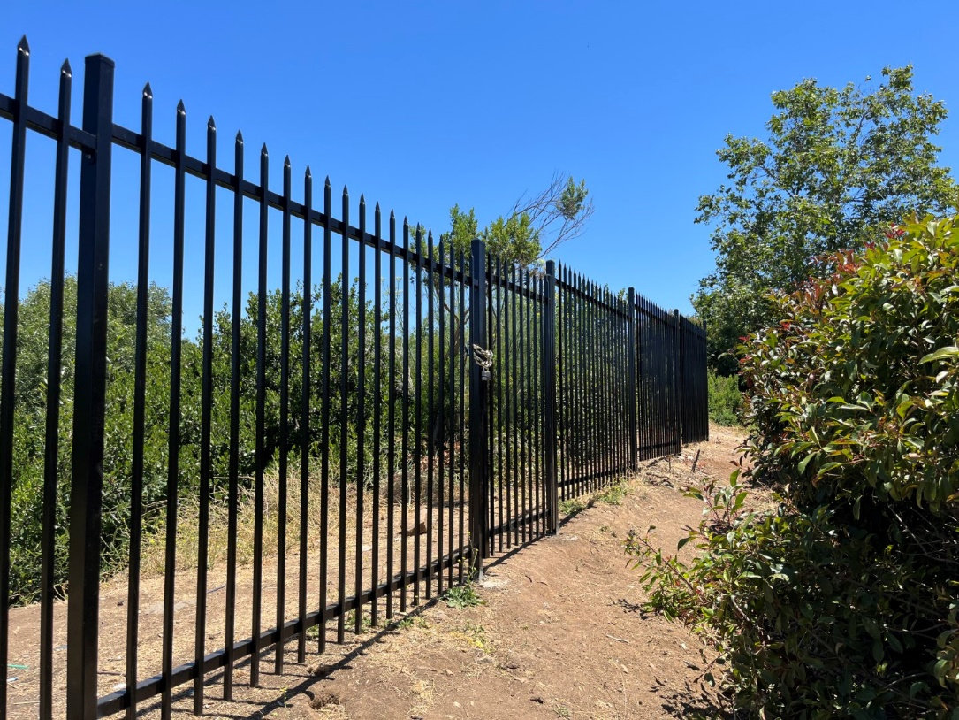
Photo 11. Portion of fencing installed at Quarry Creek Preserve (July 11, 2023)

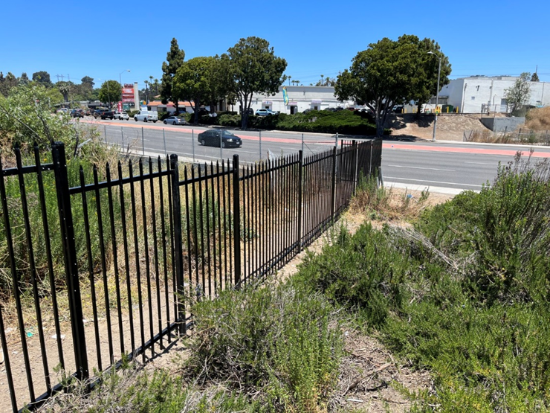
Photo 12. Portion of fence installed at Quarry Creek Preserve (July 11, 2023)

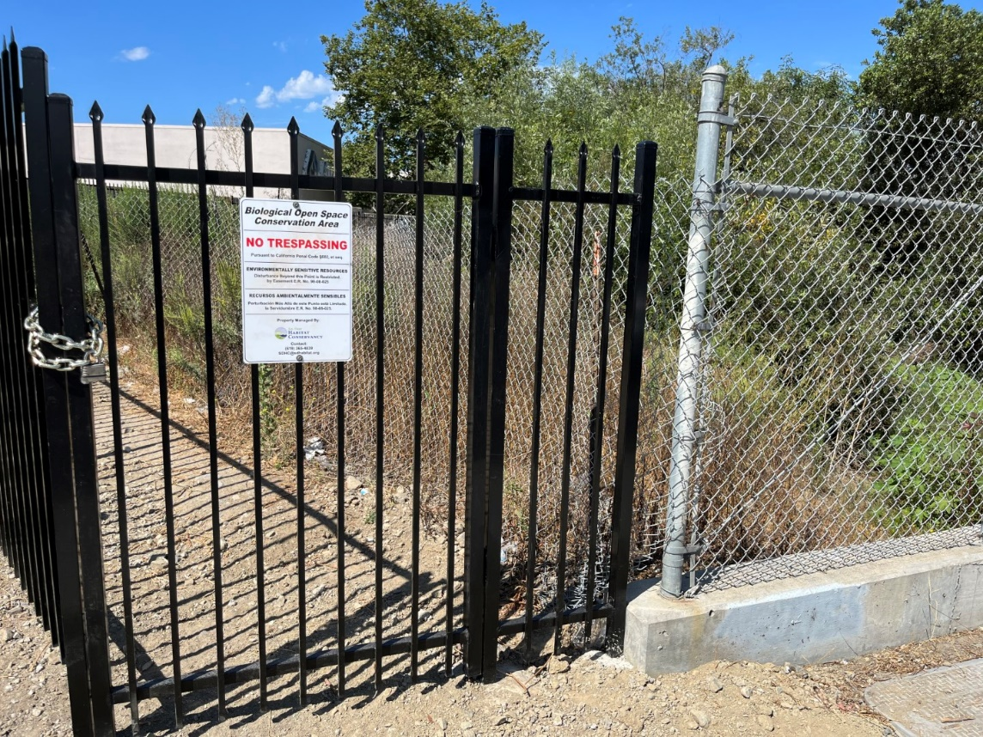
Photo 13. Gate and fence installed at Quarry Creek Preserve (August 16, 2023)

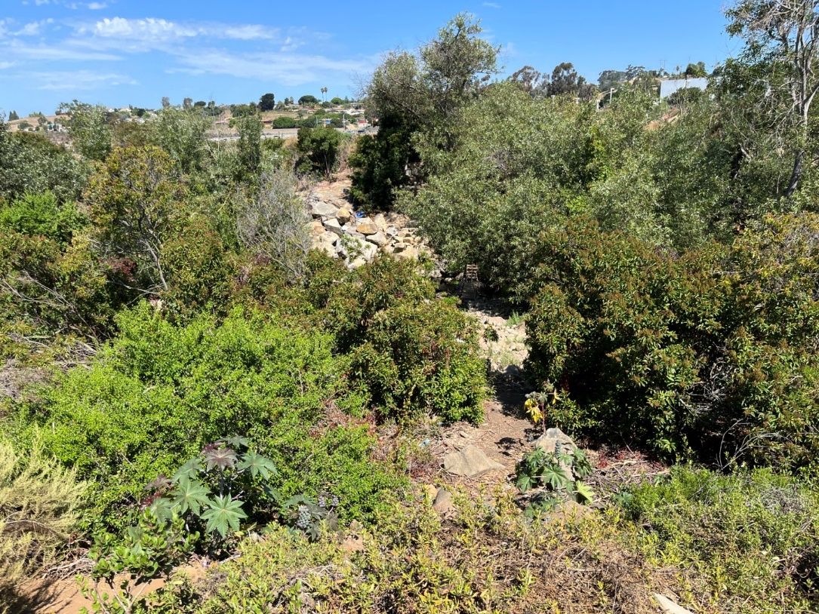
Photo 14. Quarry Creek Preserve, Free of Trash and Encampments (August 16, 2023)
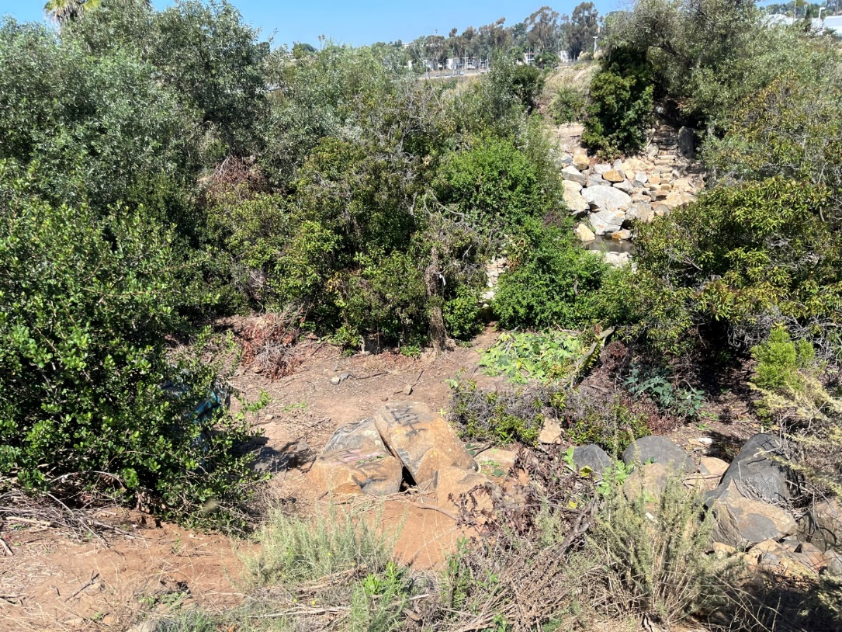
Photo 15. Quarry Creek Preserve, Free of Trash and Encampments (August 15, 2023)

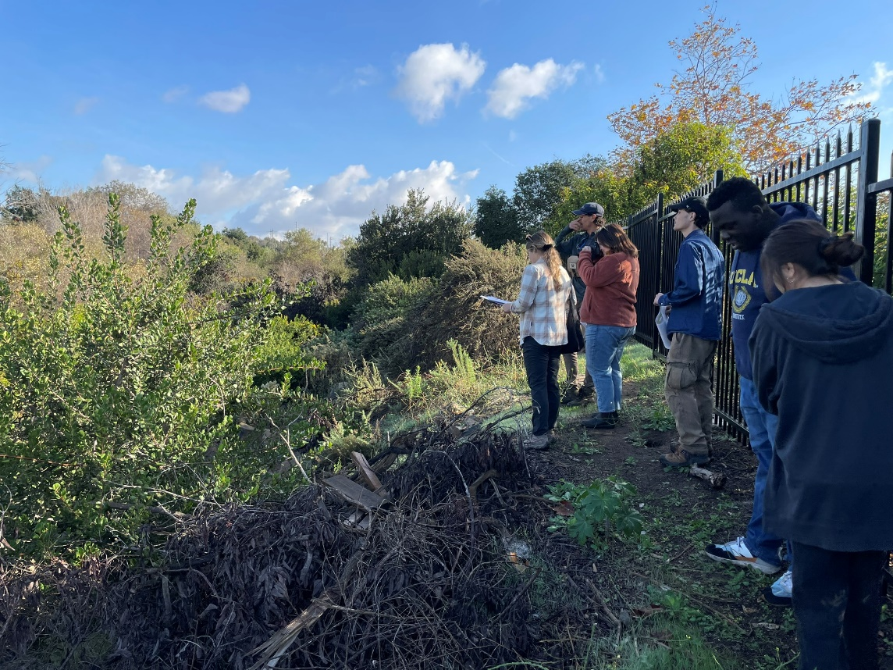
Photo 16. SANDAG staff and SDHC Staff and Interns at Quarry Creek Preserve (December 1, 2023)

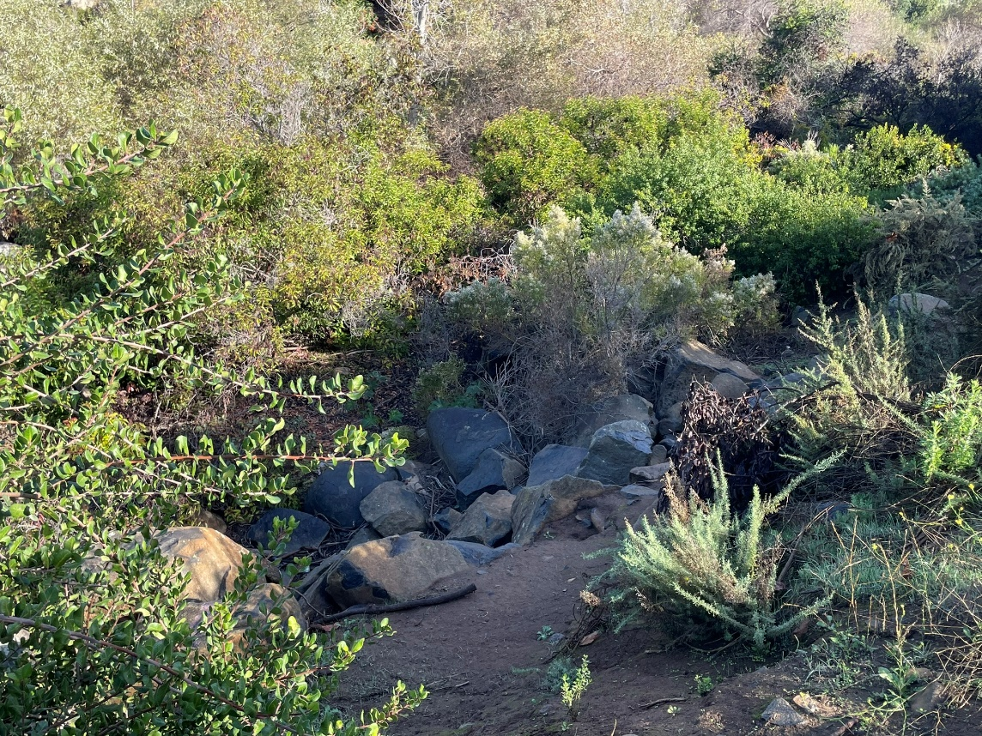
Photo 17. Quarry Creek Preserve, Free of Trash and Encampments (December 1, 2023)

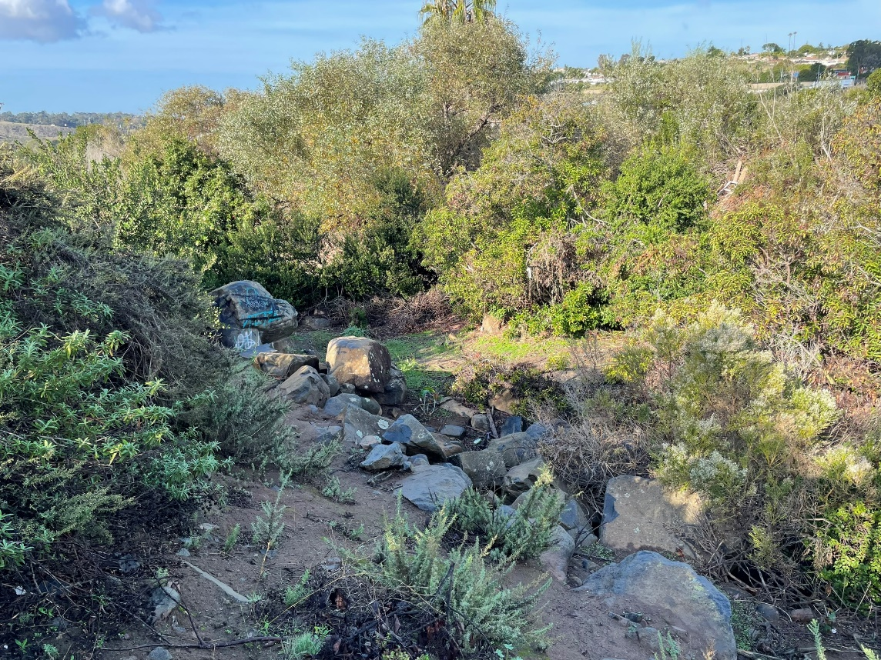
Photo 18. Quarry Creek Preserve, Free of Trash and Encampments (December 1, 2023)

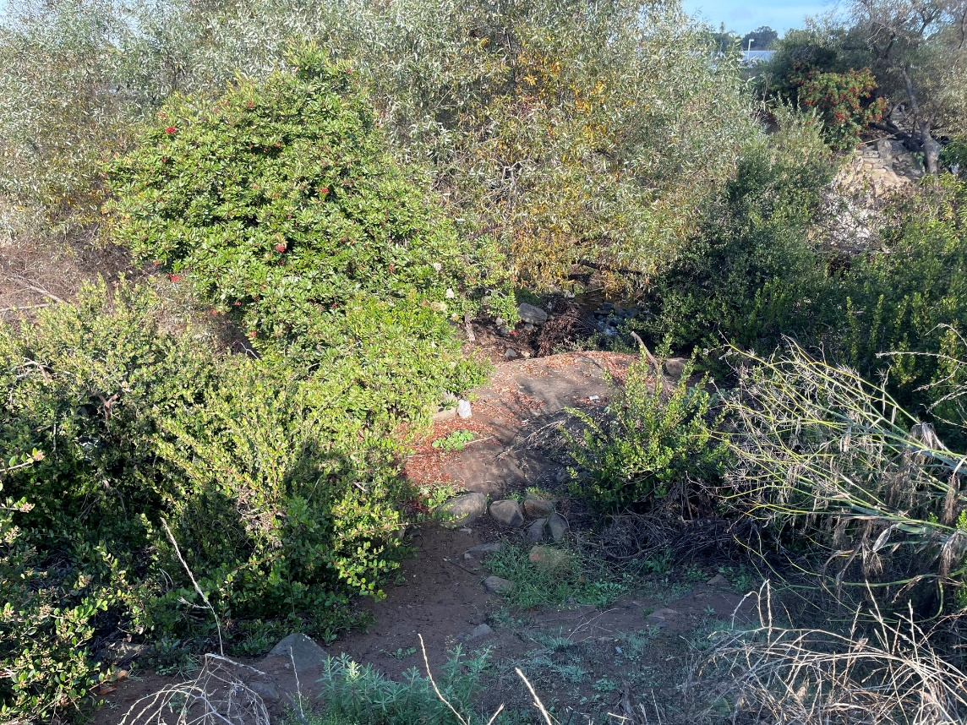
Photo 19. Quarry Creek Preserve, Free of Trash and Encampments (December 1, 2023)

Conclusions
With the goals set to install additional fencing and remove most trash in the Preserve target area, this project was a success. We garnered support from neighboring property owners to get additional funding for more fencing and engaged the community to host two large cleanup events. One suggestion would be to have a quicker grant award process. The delay in the notice-to-proceed set back our original timeframe, which took additional time to coordinate with the fence contractor and led to increased costs for the fencing. However, the fence has already proven to be effective in preventing nearly as many encampments and large quantities of trash from entering the Preserve. The causes of homelessness and trespassing are multifaceted, and we know these will be ongoing issues, but this fence has at least helped to slow down the degradation of the habitat and allow us to better combat these disturbances. We will continue our security patrols in this portion of the Preserve, as well as coordination with local authorities to remove trespassers, and will remove trash and repair the fencing as needed. Given the amount of cleared and disturbed vegetation, we also recommend restoring these disturbed areas. This will either occur as passive revegetation or active restoration if we can secure additional funding.

Geographical Information Systems Data
Please provide GIS data or mapping if applicable to the project. If GIS data or maps are included:
- Spatial data should accompany all Performance Measures as either a point, line, polygon, or list of coordinates.
- Spatial data should be attached to San Diego Management and Monitoring Program’s (SDMMP’s) website project page and shared publicly except when it absolutely necessary to keep private. If the data needs to private, please reach out to (smccutcheon@usgs.gov) or Emily Perkins (eperkins@usgs.gov).
- Spatial data should be provided as either a shapefile, KML/KMZ, or spreadsheet of coordinates.
  - Treated or planted areas should be tracked as points or polygons.
  - Fencing or trails should be tracked as lines.
- Spatial data should have the following attributes:
  - Date of Activity,
  - Type of Activity,
  - Area or Length Completed,
  - Goal Area or Length, and
  - Any notes specific to the activity.

SDMMP Project Page
To complete the grant requirements, your Final Report (along with all annual or interim reports) must be added to your project’s Project Page on the SDMMP website. Add any necessary photographs to the photo carousal and fill out the photograph information. Please contact Sarah McCutcheon (smccutcheon@usgs.gov) or Emily Perkins (eperkins@usgs.gov) if you are having trouble accessing or editing your project page.

Performance Measures
Please include the Project’s Performance Measures with the cumulative data from the entire project in order to complete the grant requirements.
*Insert Excel Icon Spreadsheet here*

Appendices
A map of Quarry Creek Preserve biological resources and fencing is appended to this report as Figure 1. Note in Figure 1, that the “SDHC Fence” is the fence that was constructed as part of this project. A compilation of the log reports from the Habitat Manager’s field coordination and cleanup efforts is included in this report as Attachment A.

State of Preserve Monitoring
SDMMP and SANDAG will be collecting specific data from each grant project in order to update the Status of the Regional Preserve System in Western San Diego County. Information collected will become available on SDMMP’s Dashboard.
To access the State of Preserve Monitoring Excel Spreadsheet:
- Please fill out the spreadsheet by simply double-clicking the State of Preserve Monitoring chart.
  - The excel sheet will open up and allow you to input data. Once you are finished inputting the data into the excel sheet, scroll the excel sheet to the top with the headers displayed. Then simply click once on the grey space to the right of the excel sheet to return to the Word document to resume editing.

Definitions
- Management Strategic Plan (MSP): The Management and Monitoring Strategic Plan for Conserved Lands in Western San Diego County: A Strategic Habitat Conservation Roadmap (or simply "MSP Roadmap" or "MSP") is a comprehensive, landscape-scale adaptive management and monitoring framework for prioritized species and vegetation communities in western San Diego County.
- Habitat Type: Please select from one of the MSP listed habitats. If the habitat type is not listed, please do not select from the dropdown and manually type in the habitat type name. Provide acreage by specific habitat types, do not combine multiple habitat types with one acreage calculation.
- Habitat Enhancement through Invasive Species Control (acres): removing invasive plant or animal species to improve ecological function.
- Habitat Created/Restored (acres): establishing habitat where it did not exist before; returning a damaged site to a natural or native state.
- Fencing (feet): fencing installed for grant purposes to lessen a threat or stressor to habitat
- Acres Requiring Management: activities such as vegetation thinning, invasive plant treatment, etc. that are necessary for maintaining previous enhancement, restoration, or creation efforts.
- Acres Requiring Monitoring: any regular monitoring conducted to establish baseline and/or determine success of grant project.
- Sensitive Species: MSP SL, SO and SS Species (https://sdmmp.com/msp_doc.php; Section 2.8 and 2.9; Table V1.1-1) that the management actions of the project are specifically designed to benefit to help ensure the species persists over the long-term on Conserved Lands in the Management Strategic Plan Area.
- Sensitive Species Planted: List any sensitive plant species that were seeded/planted for this project
- Sensitive Species Benefitted: List any other sensitive species that will or already have directly benefitted from the project

