San Diego Association of Governments
Quarry Creek Preserve Fencing Project
San Diego Habitat Conservancy
Quarterly Progress Report
Reporting Period: July 1-September 30, 2023
Submission Date: October 20, 2023
SANDAG Contract Number: S1125500

Quarterly Status Report Overview
PLEASE DO NOT CHANGE OR ALTER THE FORMATTING OF THIS DOCUMENT! SANDAG has developed a standardized grant monitoring and tracking program for the Environmental Mitigation Program (EMP) Land Management Grant Program. The purpose is to collect information on individual projects and the grant program as a whole for reporting to the Regional Habitat Conservation Taskforce, SANDAG Policy Advisory Committees, and the SANDAG Board of Directors. SANDAG monitors grantees through invoices, progress reports, performance measures, and designated photograph points. These standardized reporting templates and instructions for submittal are included below.

Work Performed this Period:

Task 1- Install Wrought Iron Fencing
Scott Fence completed installation of the 721 feet of the 6-foot tall wrought iron fence and two gates. The last day of work was on July 13, 2023. SDHC has noticed a marked reduction in encampments since the installation of the fence. This task is 100% complete.

Task 2-Trash Removal
A volunteer trash removal event was conducted on September 23, 2023 at Quarry Creek Preserve. The work was completed by 91 volunteers and 4,000 pounds of trash were removed within the 5.28-acre target area. Partners involved in the cleanup included Preserve Calavera, I Love a Clean San Diego, and the City of Oceanside. This task was 100% complete during the last reporting period and the event on September 23, 2023, is above and beyond what is required in the scope of work.

Task 3-Reporting and Invoicing
A quarterly progress report and invoice for the April 1-June 30, 2023 reporting period was prepared and submitted on July 19, 2023. The SDMMP website project page was also updated. This task is 15% complete.

Task 4- Administrative
Administrative tasks were performed throughout this reporting period and included internal meetings and coordination and coordinating with contractors. This task is 70% complete.

Work Anticipated Next Period
SDHC has completed the work on this project and expects to complete the final report and final invoice in the next reporting period.

Issues to Note
None.

Photographs & Photos

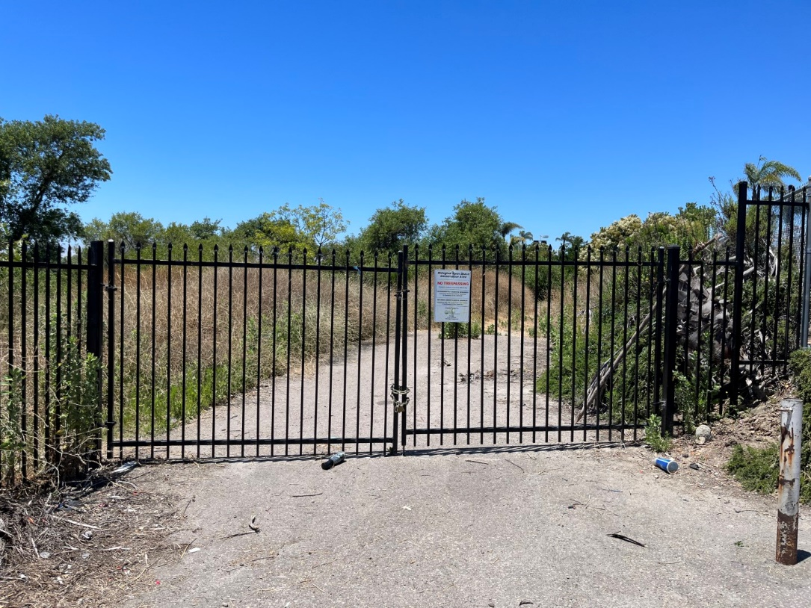
Photo 1. Gate installed at Quarry Creek Preserve, July 11, 2023

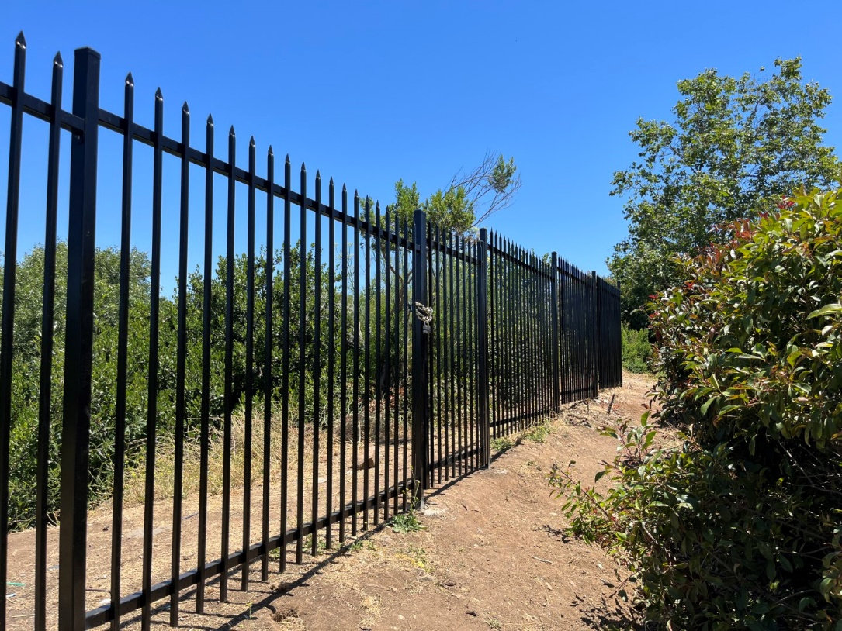
Photo 2. Portion of fencing installed at Quarry Creek Preserve, July 11, 2023
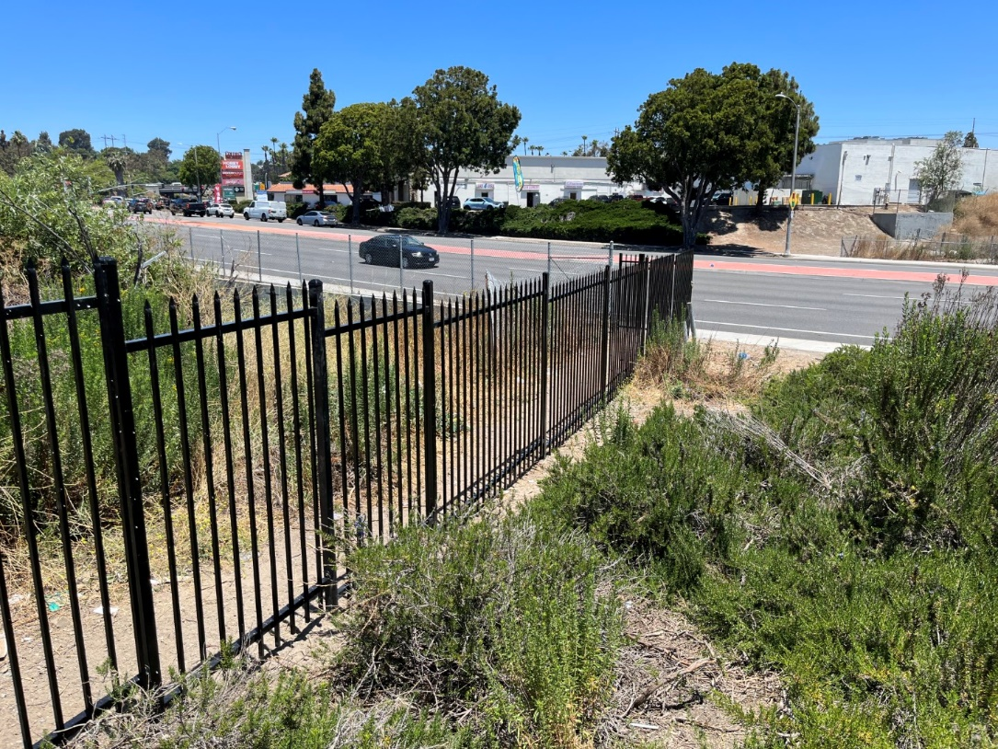
Photo 3. Portion of fence installed at Quarry Creek Preserve, July 11, 2023

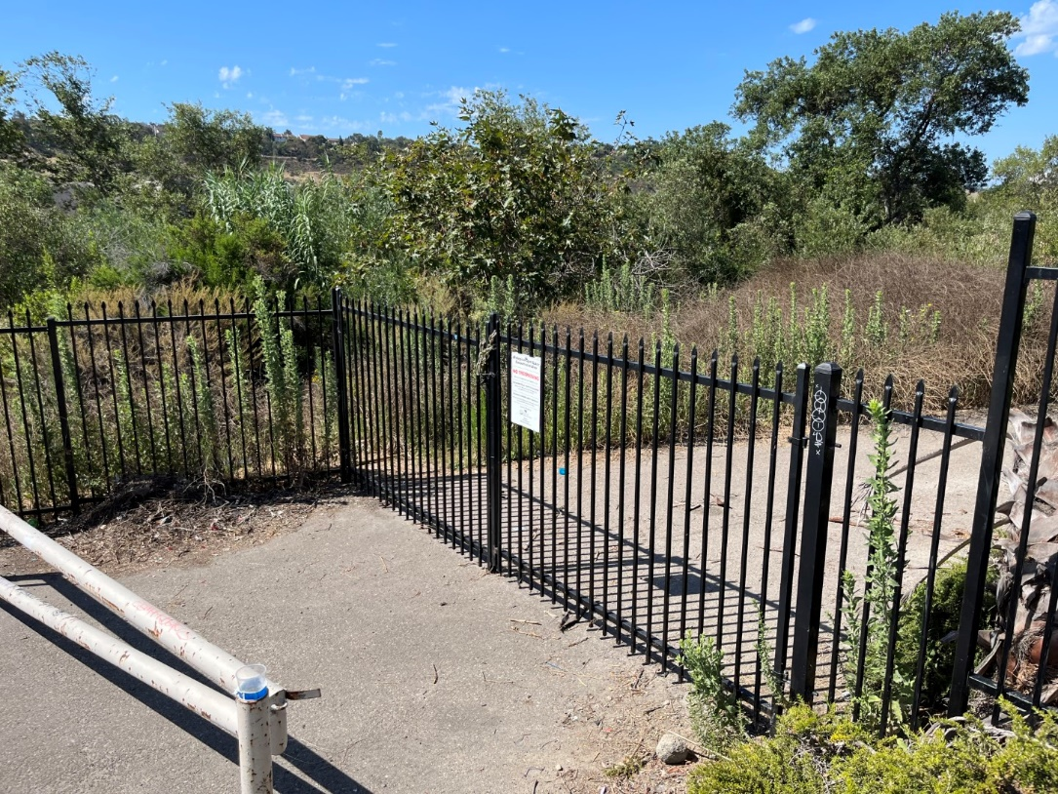
Photo 4. Gate and fence installed at Quarry Creek Preserve, August 16, 2023

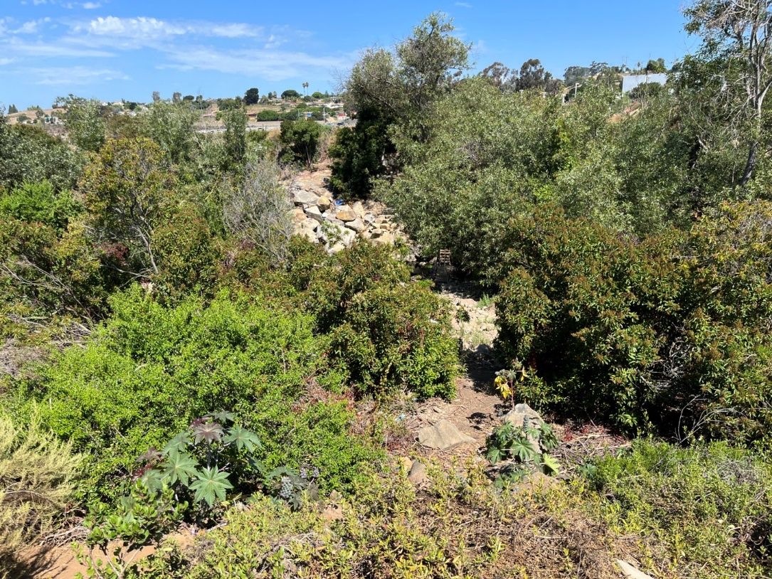
Photo 5. Quarry Creek Preserve free of encampments since fence was installed, August 16, 2023

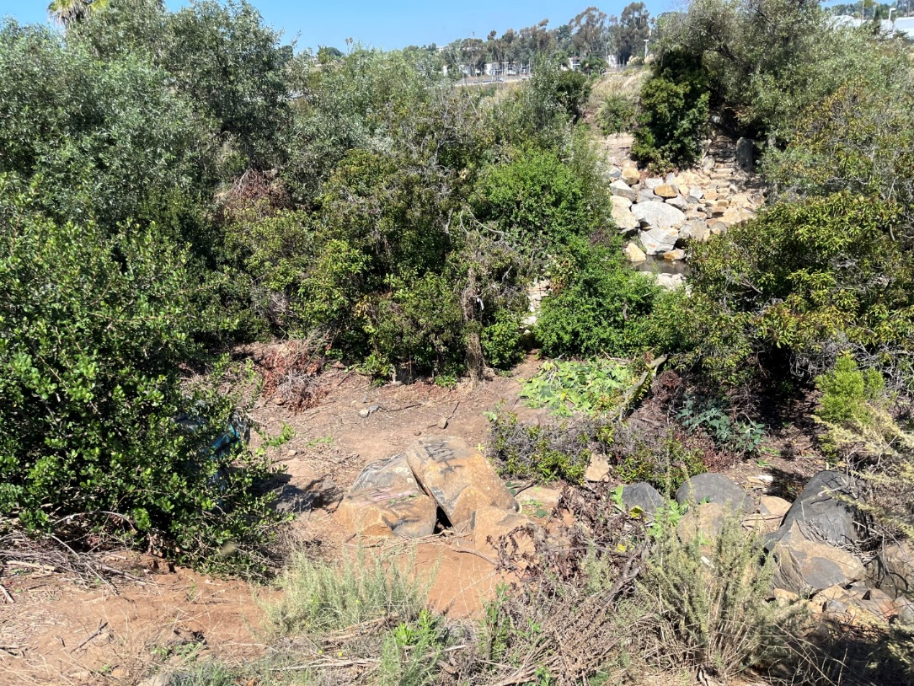
Photo 6. Quarry Creek Preserve free of encampments since fence was installed, September 23, 2023

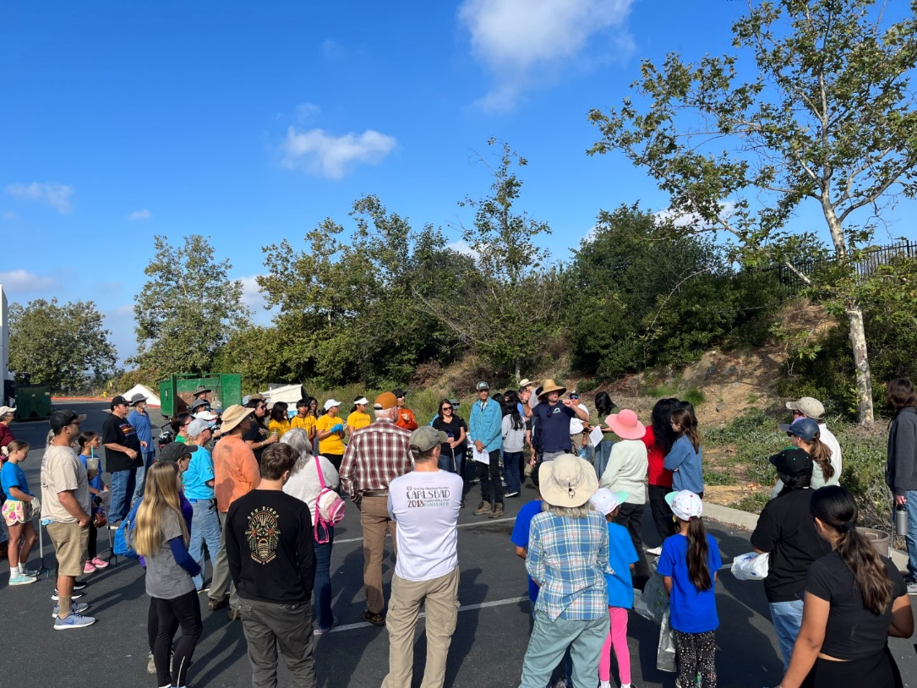
Photo 7. Volunteers gathering outside the Quarry Creek Preserve for a trash cleanup event, September 23, 2023
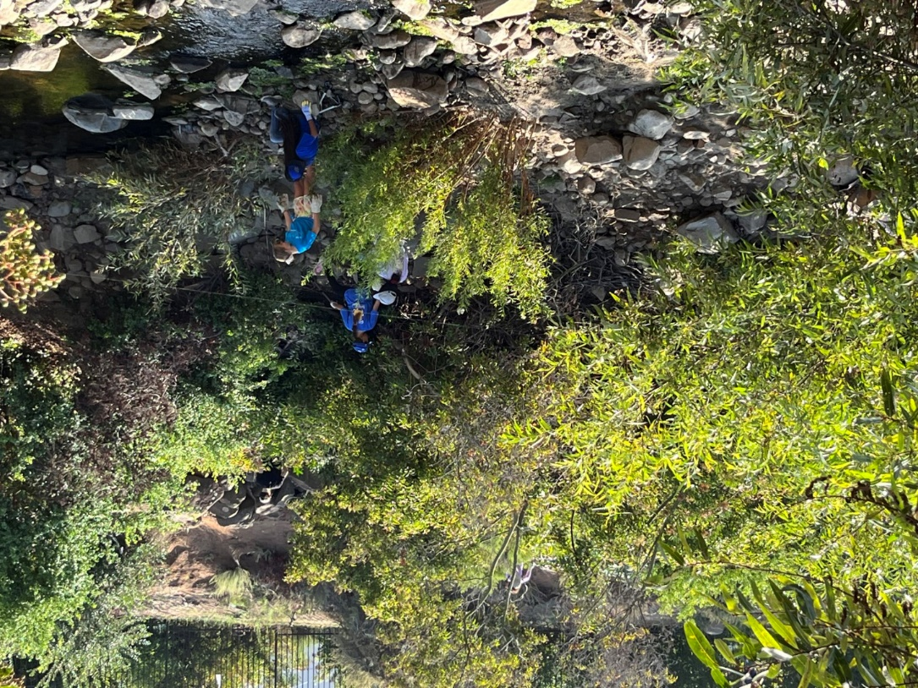
Photo 8. Volunteers picking up trash along the creek at Quarry Creek Preserve, September 23, 2023

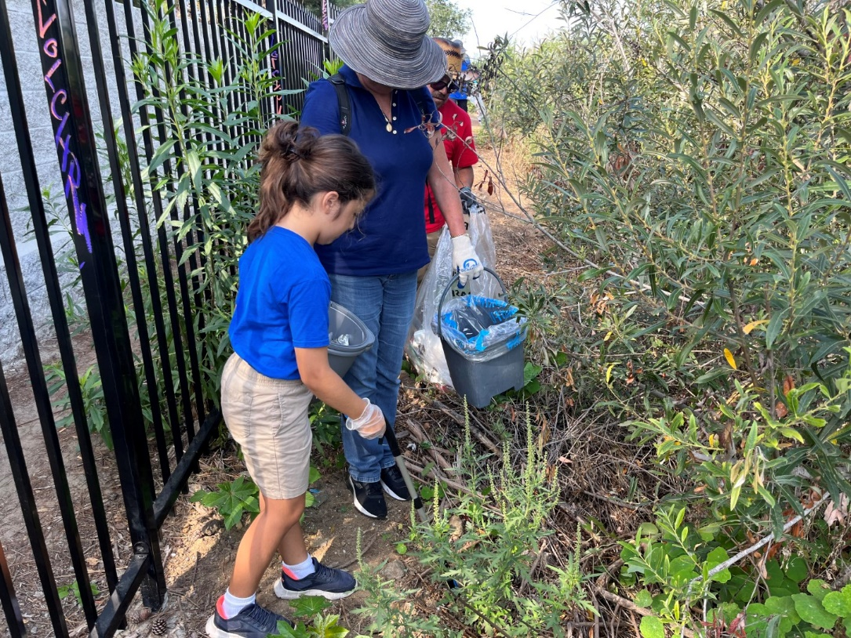
Photo 9. Volunteers picking up trash at Quarry Creek Preserve, September 23, 2023

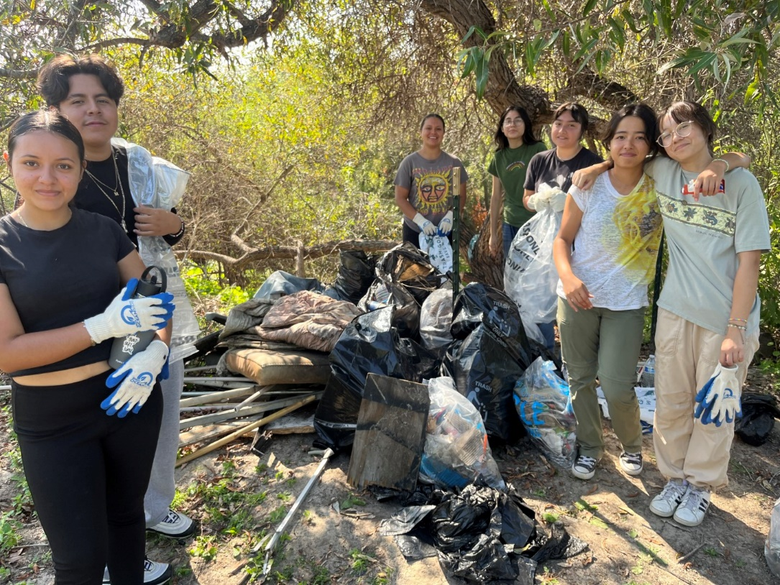
Photo 10. Volunteers posing for a picture next to all the trash they gathered at Quarry Creek Preserve, September 23, 2023
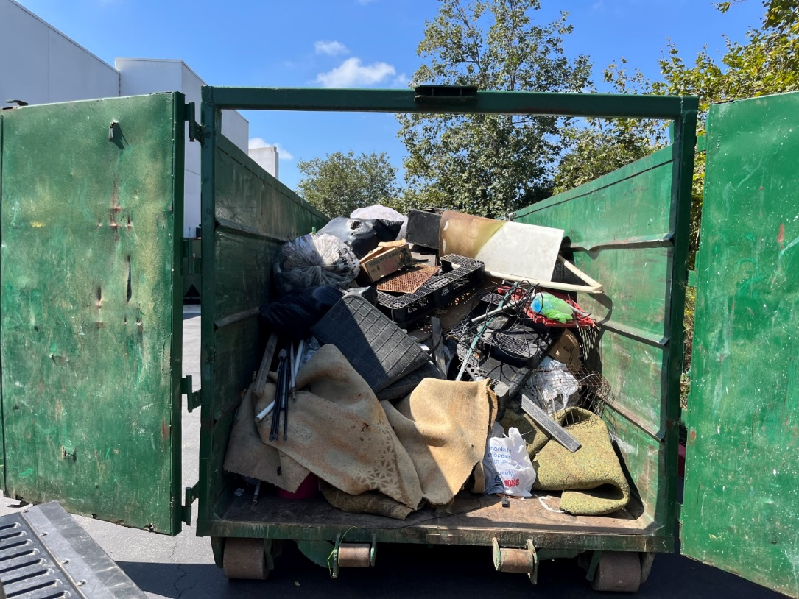
Photo 11. Trash collected by volunteers being hauled out at Quarry Creek Reserve, September 23, 2023

SDMMP Project Page
To receive reimbursement for work conducted within the quarter, submission of Quarterly Progress, Annual, and Final Reports must be added to your project’s Project Page on the SDMMP website. Add any necessary photographs to the photo carousal and fill out the photograph information. Please contact Sarah McCutcheon (smccutcheon@usgs.gov) or Emily Perkins (eperkins@usgs.gov) if you are having trouble accessing or editing your project page.

Performance Measures
Please include the Project’s Performance Measures for each Quarterly Invoice and Progress Report in order to receive reimbursement.

