San Diego Association of Governments
Quarry Creek Preserve Fencing Project
San Diego Habitat Conservancy
Quarterly Progress Report
Reporting Period: April 1-June 30, 2023
Submission Date: July 19, 2023
SANDAG Contract Number: S1125500

Quarterly Status Report Overview
PLEASE DO NOT CHANGE OR ALTER THE FORMATTING OF THIS DOCUMENT! SANDAG has developed a standardized grant monitoring and tracking program for the Environmental Mitigation Program (EMP) Land Management Grant Program. The purpose is to collect information on individual projects and the grant program as a whole for reporting to the Regional Habitat Conservation Taskforce, SANDAG Policy Advisory Committees, and the SANDAG Board of Directors. SANDAG monitors grantees through invoices, progress reports, performance measures, and designated photograph points. These standardized reporting templates and instructions for submittal are included below.

Work Performed this Period:

Task 1- Install Wrought Iron Fencing
Work on this task began immediately after the notice-to-proceed on April 21, 2023. SDHC staff and fencing contractor, Scott Fence, met with Gafcon regarding the Labor Compliance Pre-Con meeting on April 25, 2023. On June 6, 2023, Scott Fence and SDHC’s Habitat Manager, Vince Rivas, met at Quarry Creek Preserve to discuss and mark the placement of the fencing and go over the final fence plan.
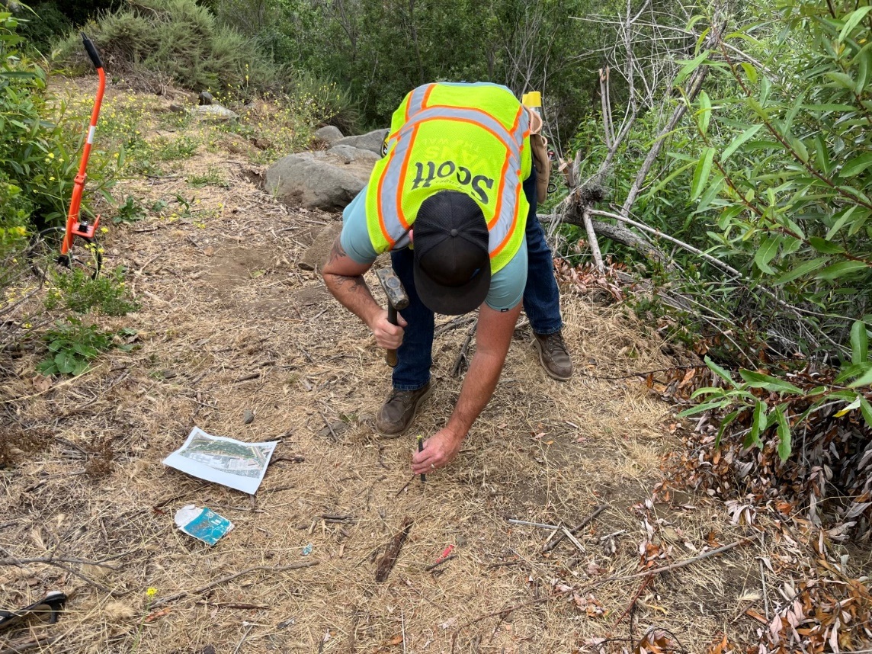
Photo 1. A representative from Scott Fence marking the spot where the fencing will be placed (June 6, 2023)
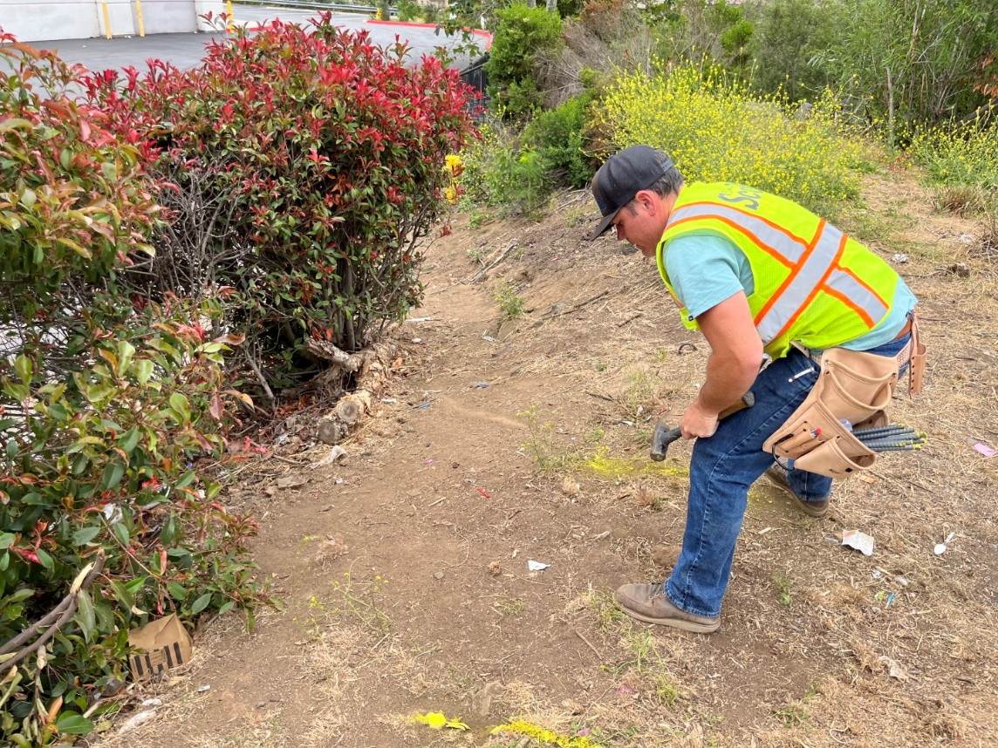
Photo 2. Scott Fence representative marking the ground where the gate will be installed (June 6, 2023)

Though not part of the EMP Land Management Grant, SDHC hired a contractor, Black Sage Environmental, to conduct trespasser removal with the Oceanside Police Department to ensure no individuals would be contained within the area once the fencing was complete. Black Sage Environmental conducted site visits and trespasser removal on June 4, 12, and 25, 2023.
Scott Fence began installation of the 6-foot tall wrought iron fence on June 12, 2023. This included the installation of 14 gauge posts with concrete footings. After the fence posts were installed, Scott Fence installed 14 gauge rails, 16 gauge pickets, fencing panels, and two gates.

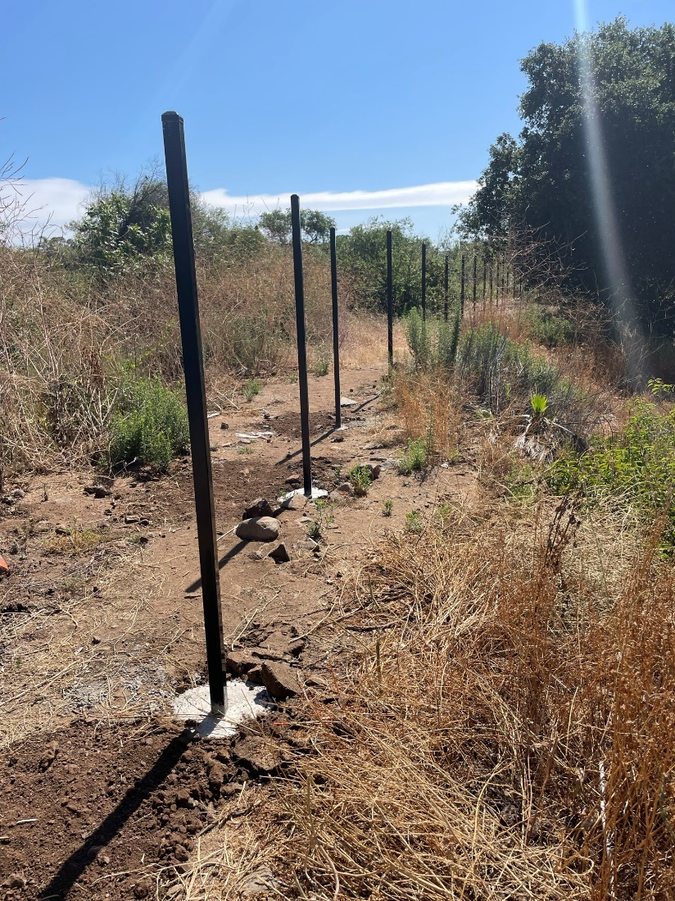
Photo 3. Fence posts installed in concrete footings (June 20, 2023)
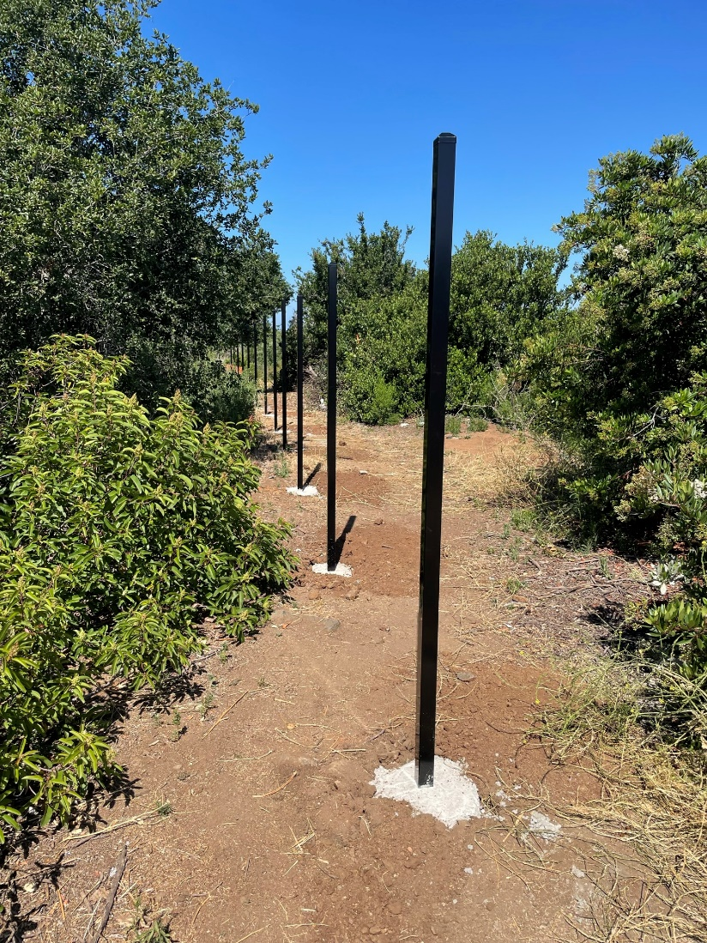
Photo 4. Fence posts installed in concrete footings (June 20, 2023)

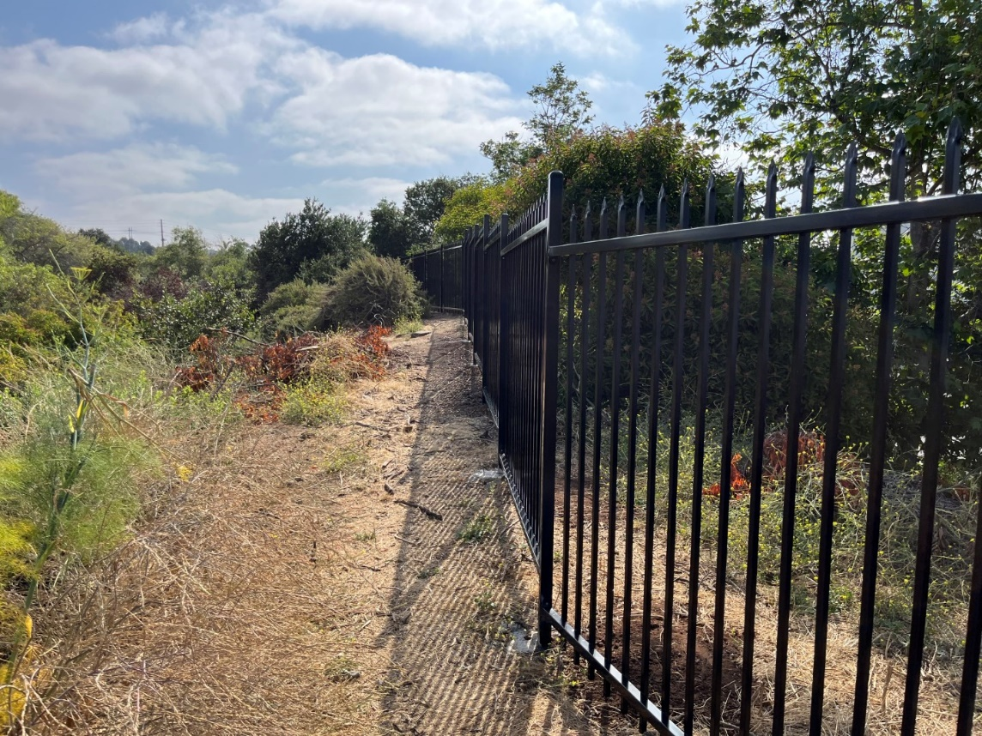
Photo 5. Portion of the installed fence along the boundary of Quarry Creek Preserve (June 30, 2023)
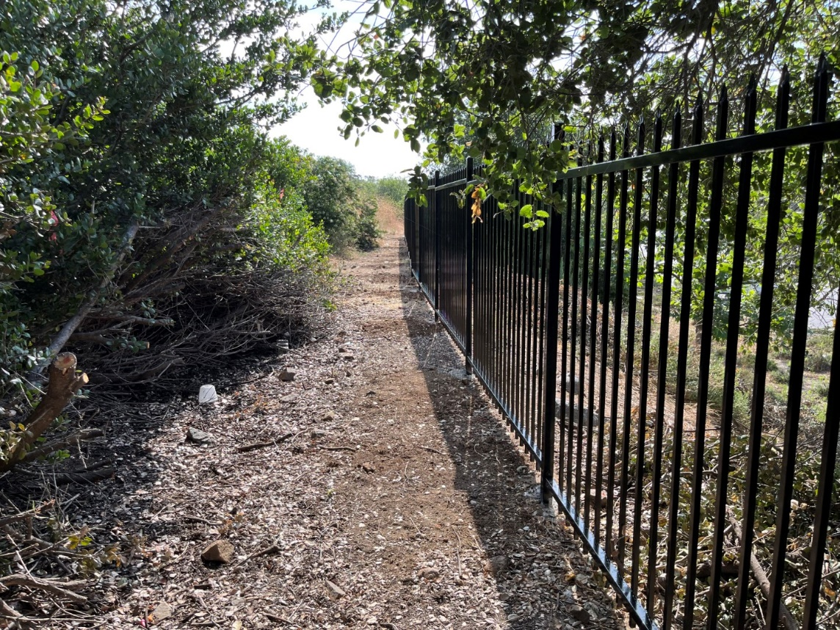
Photo 6. Portion of the installed fence along the boundary of Quarry Creek Preserve (June 30, 2023)

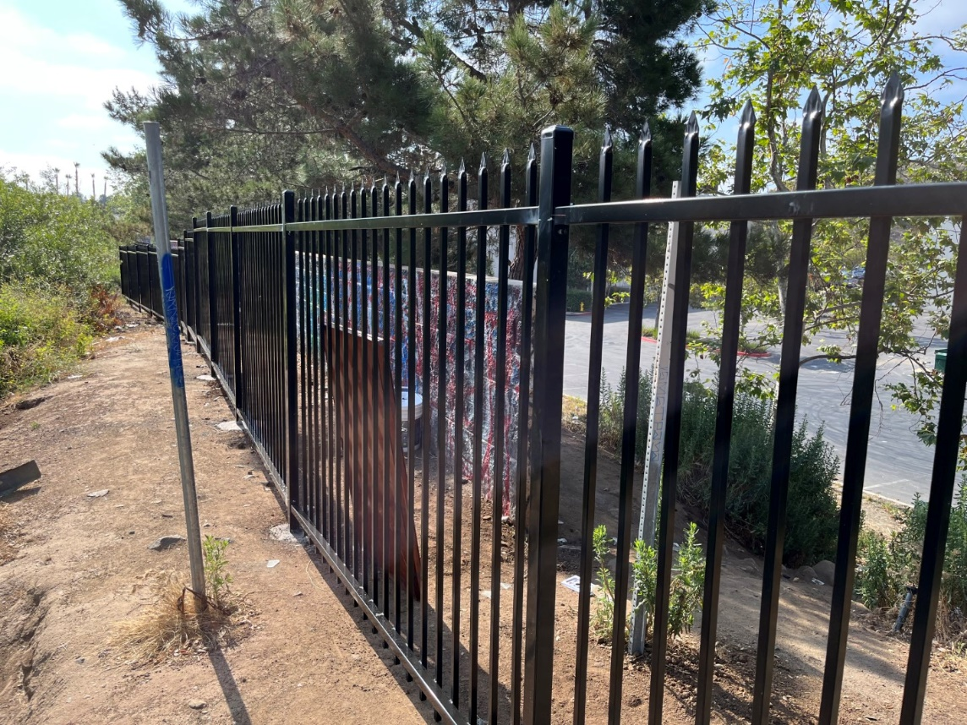
Photo 7. Fencing installed along the Preserve boundary, at a high-trespass entry point behind the adjacent shopping center (June 30, 2023)
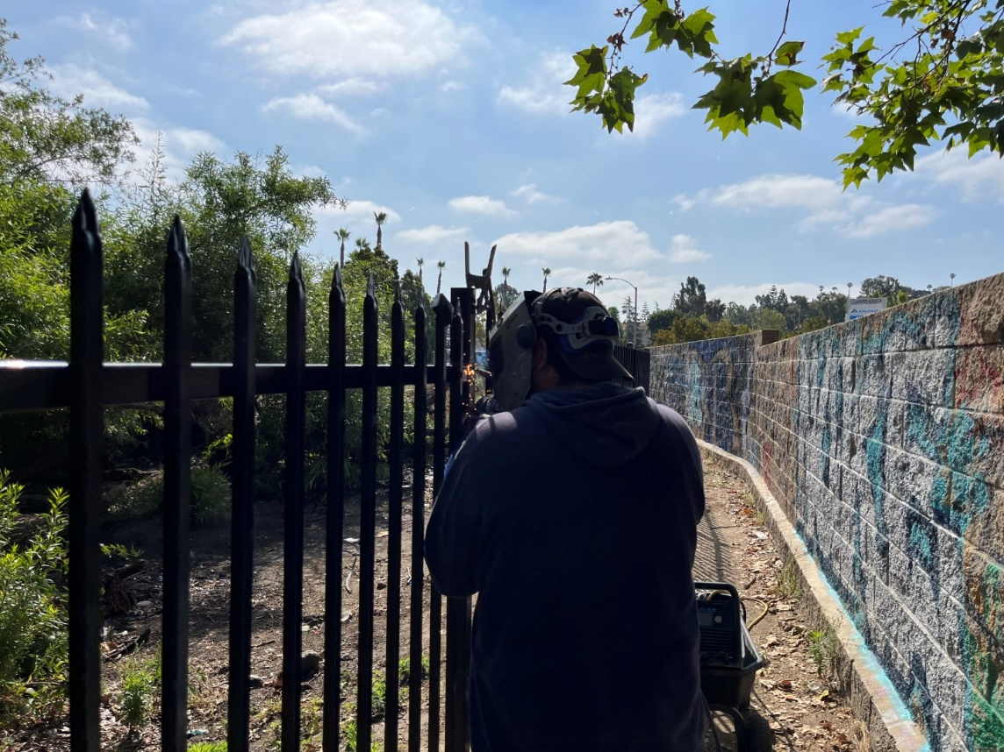
Photo 8. Scott Fence staff installing the fence (June 30, 2023)

The fence is 80% complete during this reporting period and is expected to be 100% complete by mid-July 2023.

Task 2-Trash Removal

A volunteer trash removal event was conducted on April 22, 2023 at Quarry Creek Preserve. The work was completed by 101 volunteers and 5,500 pounds of trash were removed within the 5.28-acre target area. Partners involved in the cleanup included Preserve Calavera, I Love a Clean San Diego, and the City of Oceanside. This task is 100% complete.
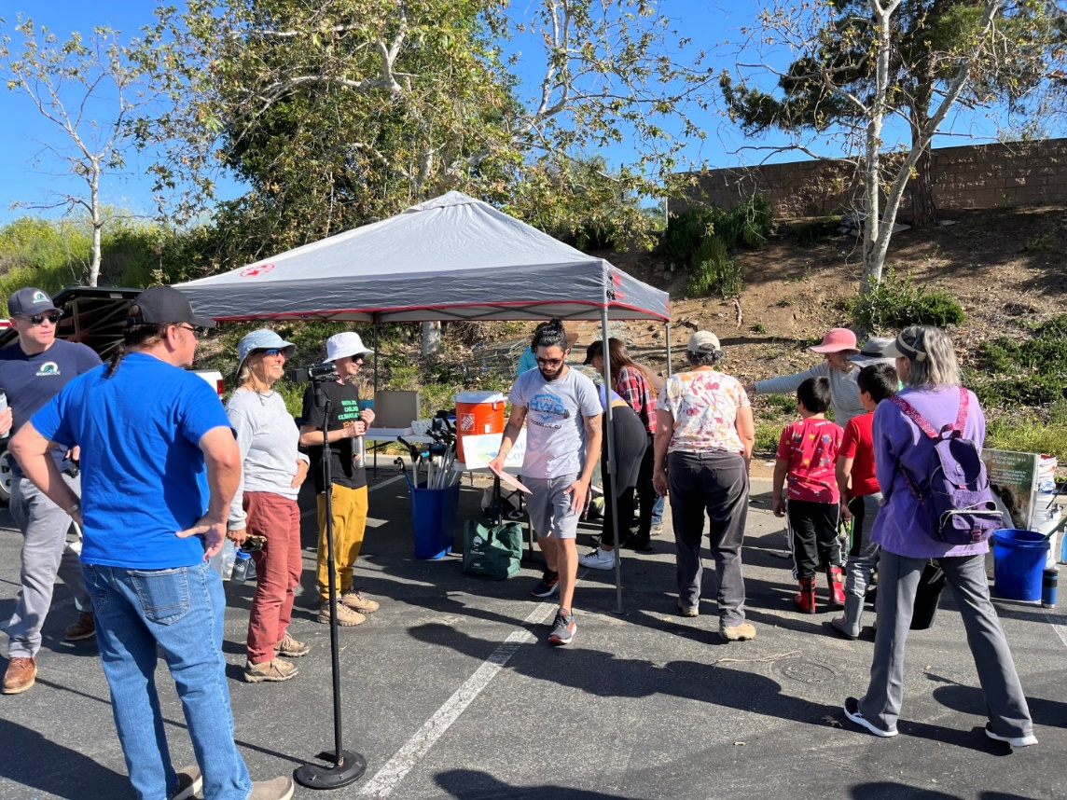
Photo 9. Volunteers meeting in the parking lot abutting the Preserve (April 22, 202)3

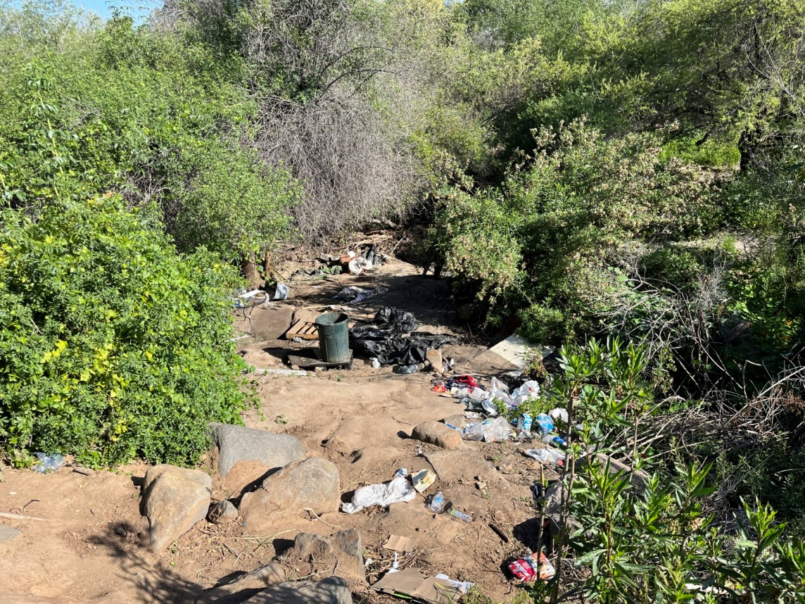
Photo 10. Trash strewn throughout the creek (April 22, 2023)
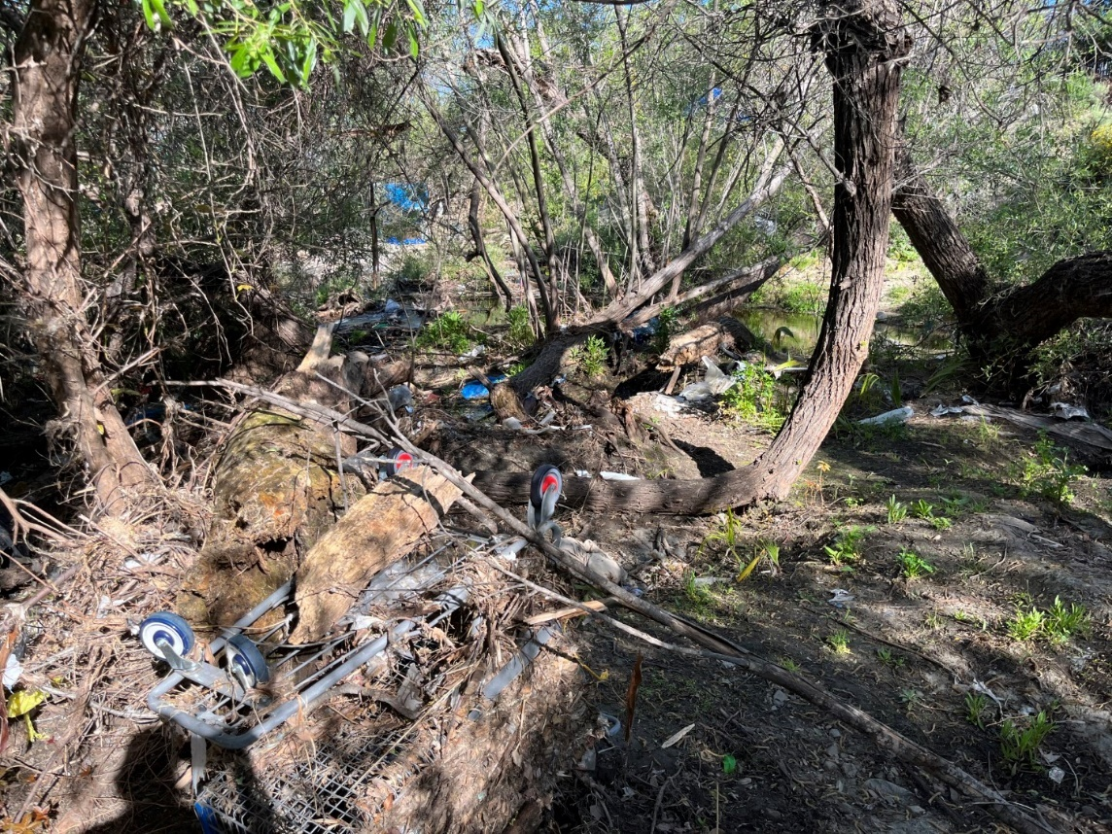
Photo 11. Trash dumped in the Preserve (April 22, 2023)
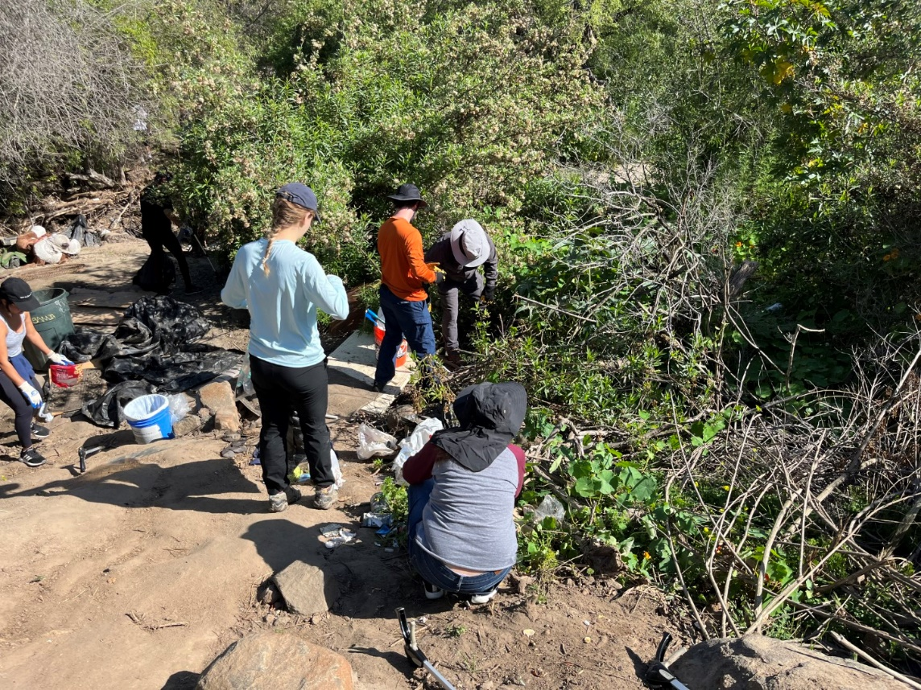
Photo 12. Volunteers picking up trash in the Preserve (April 22, 2023)
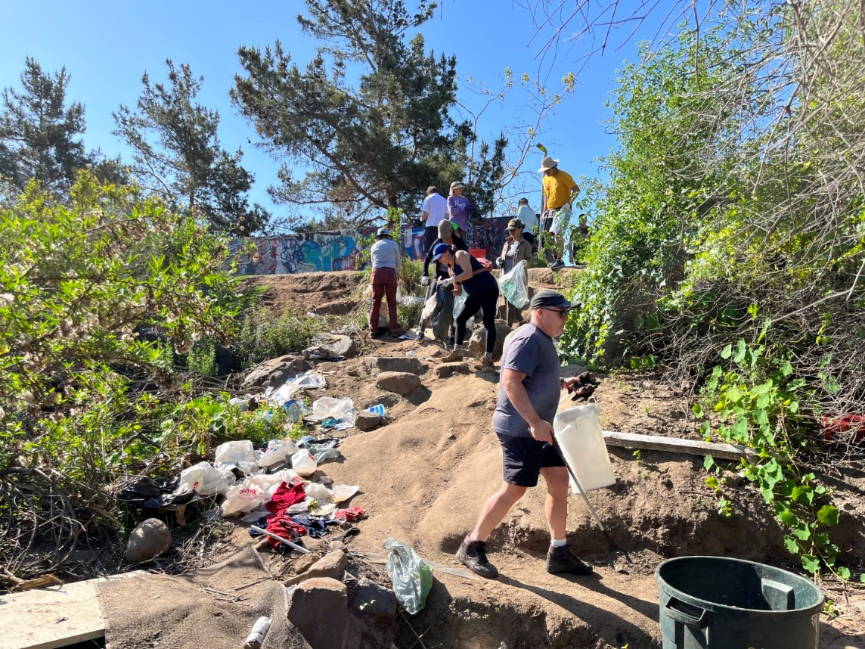
Photo 13. Volunteers picking up trash near the Preserve boundary (April 22, 2023)
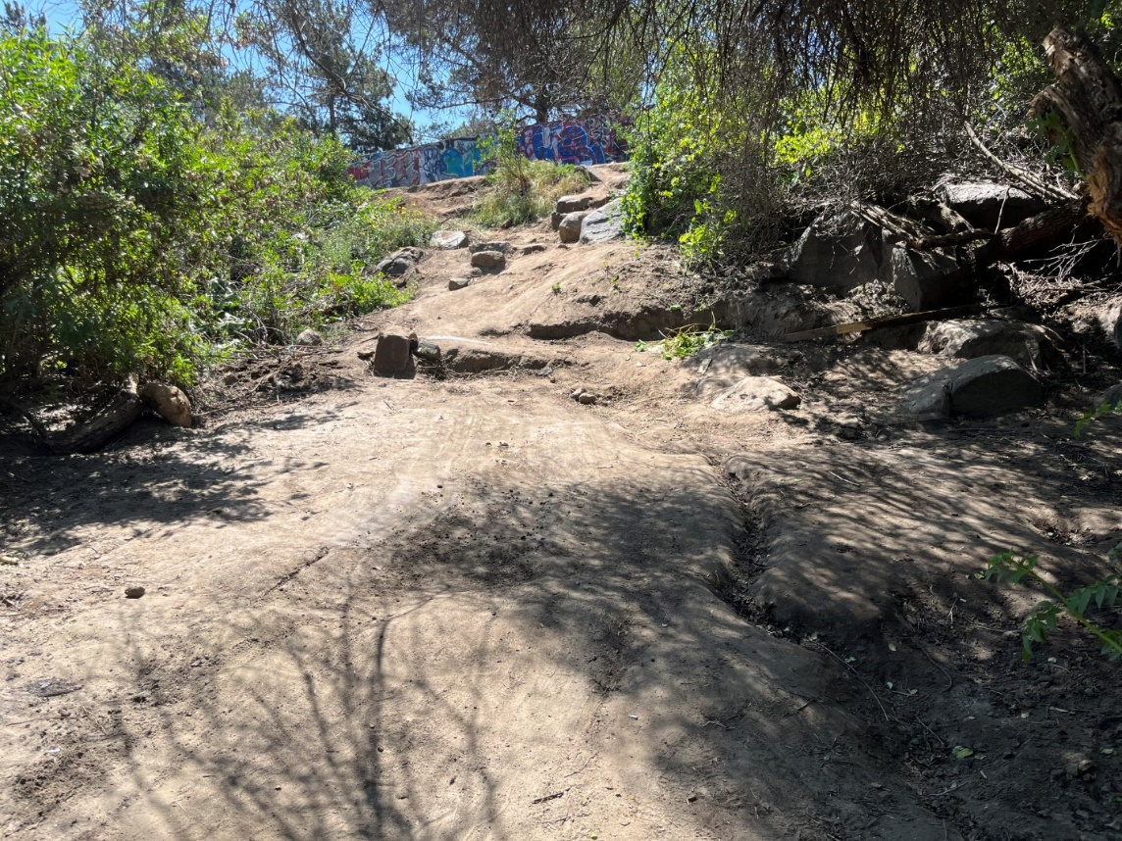
Photo 14. The same area in Photo 13, after the trash was removed by volunteers (April 22, 2023)

Task 3-Reports

No reporting or invoicing occurred within the reporting period. This task is 0% complete.

Task 4 - Administrative

Task 4 began on April 21, 2023 when SDHC received the Notice-to-Proceed. Activities under this task included project set up, coordinating with contractors, and meeting with SANDAG. This task is 20% complete.

Work Anticipated Next Period
SDHC anticipates the fence and gate installation will be complete in the next reporting period. SDHC will also be completing the quarterly progress report and invoices for the April 1-June 30 reporting period.

Issues to Note
There are no issues to note.
SDMMP Project Page
To receive reimbursement for work conducted within the quarter, submission of Quarterly Progress, Annual, and Final Reports must be added to your project’s Project Page on the SDMMP website. Add any necessary photographs to the photo carousal and fill out the photograph information. Please contact Sarah McCutcheon (smccutcheon@usgs.gov) or Emily Perkins (eperkins@usgs.gov) if you are having trouble accessing or editing your project page.

Project Performance Measures Instructions
SANDAG will utilize the SANDAG Performance Measures to document compliance with the Project. Grantee’s performance will be measured against the Performance Measures (Exhibit D) during the term of the project. More details on Performance Measures and Grant Recovery Plans are outlined in the Grant Agreements.

Performance Measures
Please include the Project’s Performance Measures for each Quarterly Invoice and Progress Report in order to receive reimbursement.

