San Diego Association of Governments
Dennery Canyon Restoration Project
City of San Diego
Quarterly Progress Report
Reporting Period: 05/02/2023 – 06/30/2023
Submission Date: 07/20/2023
SANDAG Contract Number: S1125503

Quarterly Status Report Overview
The City of San Diego received the Notice to Proceed (NTP) for the Dennery Canyon Rare Restoration Project on May 2, 2023. This quarterly progress report details work performed from May 2, 2023, through June 30, 2023. Work performed during this period included qualitative site assessments, establishing photo monitoring points, focused surveys for focal rare plant species, and IMG protocol monitoring of focal plant species. All work completed during this reporting period was performed by City staff as an in-kind match; therefore, an invoice is not included with this report. Work anticipated in the next reporting period will include hiring contractors to implement Tasks 1-4, performing QA/QC and summary statistics on baseline survey data, preparing maps indicating the current extent of focal species, and coordinating with San Diego Zoo staff to collect seeds from San Diego thornmint.

Work Performed this Period:

Task 1- Area 1: SD thornmint restoration and vernal pool enhancement (1.55 acres)
Not started; anticipated start date is September 1, 2023.
Percent complete: 0%

Task 2-Area 2: SD thornmint buffer (1.54 acres)
Not started; anticipated start date is September 1, 2023.
Percent complete: 0%

Task 3-Area 3: Otay tarplant restoration (3.36 acres)
Not started; anticipated start date is September 1, 2023.
Percent complete: 0%

Area 4: San Diego ambrosia, Orcutt’s bird’sbeak, and vernal pool restoration and enhancement (2.23 acres)
Not started; anticipated start date is September 1, 2023.
Percent complete: 0%

Monitoring and Reporting
Work start date: 05/08/2023
Percent complete: 10%

City staff established four photo monitoring points, each photo point representing Task Areas 1-4, respectively. These photo monitoring points will be revisited quarterly to document changing conditions.

City staff completed annual focused surveys for San Diego thornmint (Acanthomintha ilicifolia), Otay tarplant (Deinandra conjugens), and Orcutt’s bird-beak (Dicranostegia orcuttiana) in the designated restoration and enhancement areas and surrounding habitat following the IMG protocol for monitoring MSP species. While survey results have not been thoroughly analyzed yet, there is one crucial preliminary finding to note: due to an expanded survey effort, several San Diego thornmint plants were discovered occurring outside of the proposed project area – approximately 150-feet north of the Area 1 fence line (100-feet north of the Area 2 boundary).

Administrative
Not started; anticipated start date is July 1, 2023.
Percent complete: 0%

Work Anticipated Next Period
Work anticipated in the next reporting period will include:
- Hire contractors to implement Tasks 1-4;
- Perform QA/QC and summary statistics on baseline survey data;
- Prepare maps indicating the current extent of focal species;
- Coordinate with San Diego Zoo staff to collect seeds from San Diego thornmint.

Issues to Note
- The Notice to Proceed for this grant was issued on May 2, 2023. Due to the delay in the issuance of the NTP, the timeline for active restoration and weed management activities had to be adjusted accordingly. These activities are now anticipated to start in September 2023.

- While conducting baseline monitoring surveys, biologists noted prickly goldenfleece (Urospermum picroides) was present in low numbers in Area 1 and abundant in the northern part of Area 2. This is a newly documented invasive plant species for San Diego County (see Photo 5). Weed management efforts will target this species in the project area and the City plans to seek additional funding sources to help control it outside of the project area.

Photographs & Figures
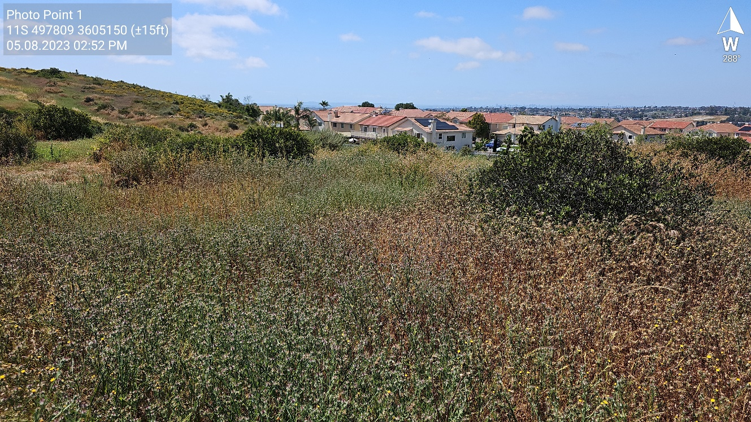
Photo 1: Photo point 1 shows baseline conditions for Area 1. Nonnative species cover in Area 1 is estimated at 90%. The most abundant nonnative species include Tocolote thistle (Centaurea melitensis), Mediterranean stork's bill (Erodium malacoides), Annual yellow sweetclover (Melilotus indicus).

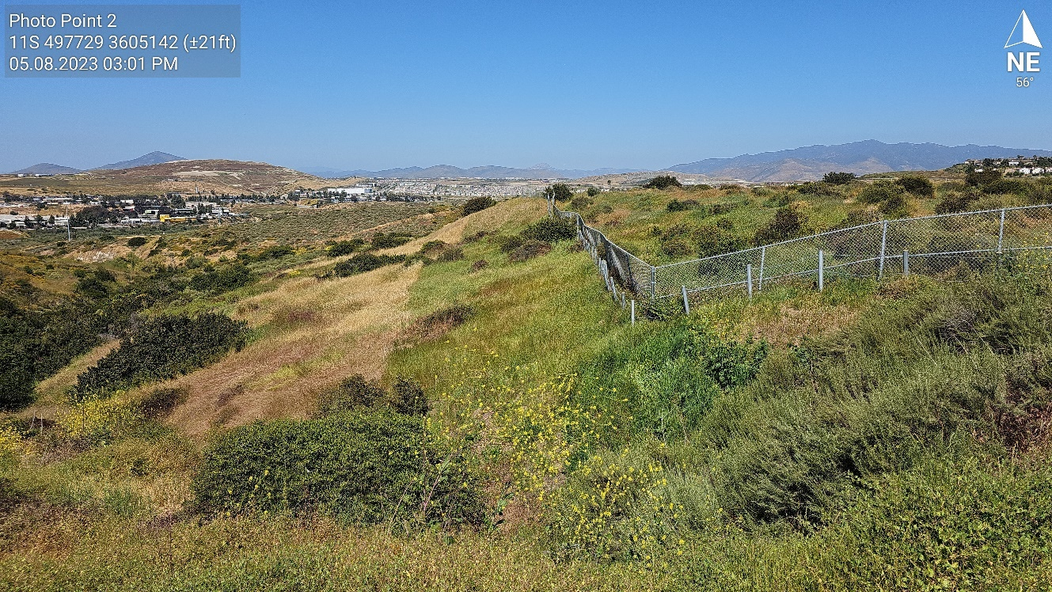
Photo 2: Photo point 2 shows baseline conditions for Area 2. Nonnative species cover in Area 2 is estimated at 80%. The most abundant nonnative species include Tocolote thistle, Italian ryegrass (Festuca perennis), slender wild oat (Avena barbata), and Mediterranean stork's bill.

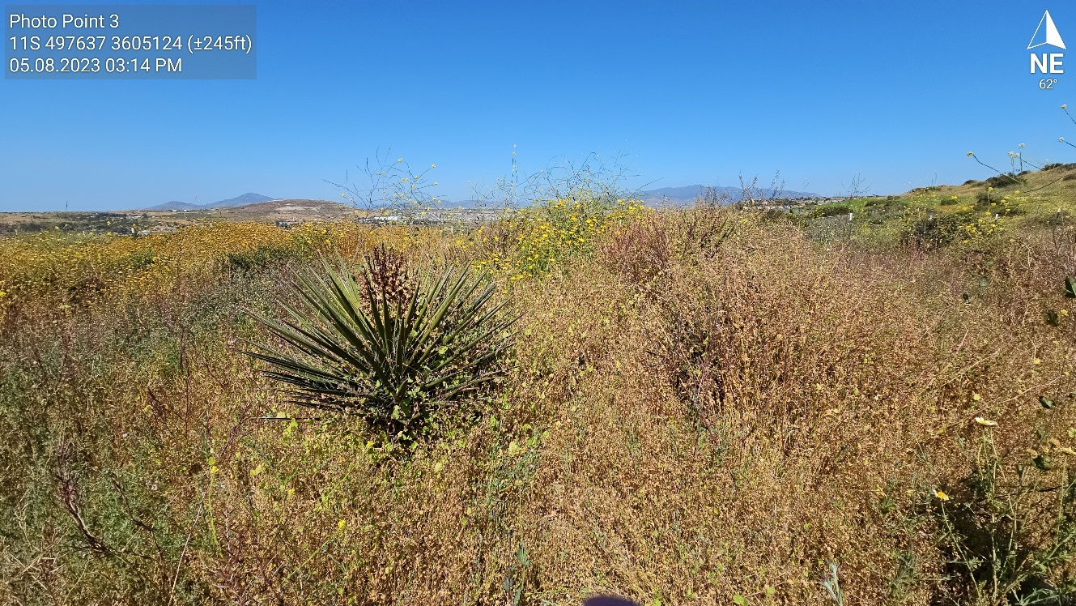
Photo 3: Photo point 3 shows baseline conditions for Area 3. Nonnative species cover in Area 3 is estimated at 90%. The most abundant nonnative species include Tocolote thistle, black mustard (Brassica nigra), crown daisy (Glebionis coronaria), and Mediterranean stork's bill.

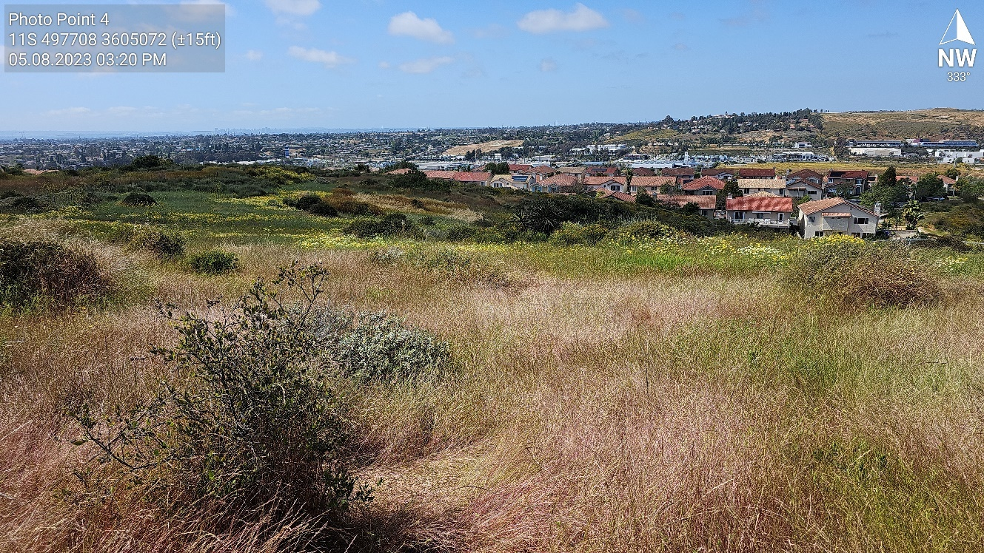
Photo 4: Photo point 4 shows baseline conditions for Area 4. Nonnative species cover in Area 4 is estimated at 85%. The most abundant nonnative species include Tocolote thistle, crown daisy, Italian ryegrass, and slender wild oat.

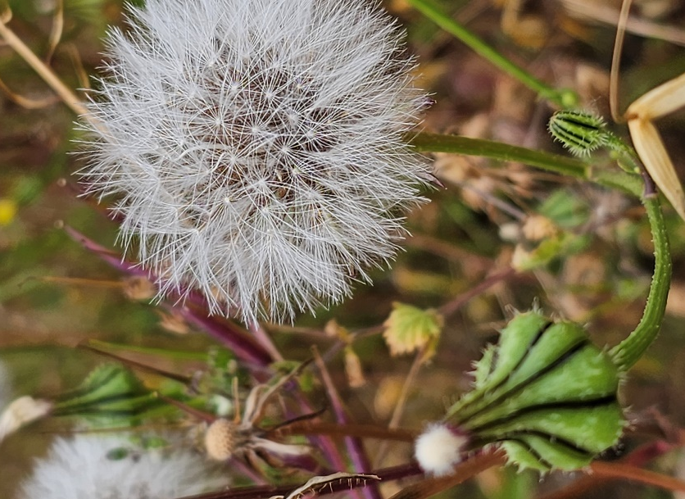
Photo 5: Prickly goldenfleece was present in low numbers in Area 1 and abundant in the northern part of Area 2. This is a newly documented invasive plant species for San Diego County.
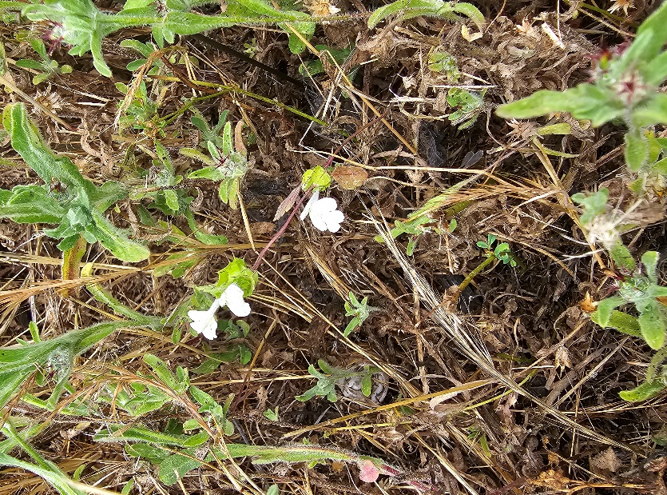
Photo 6: San Diego thornmint growing amongst invasive Tocolote thistle in Area 1.

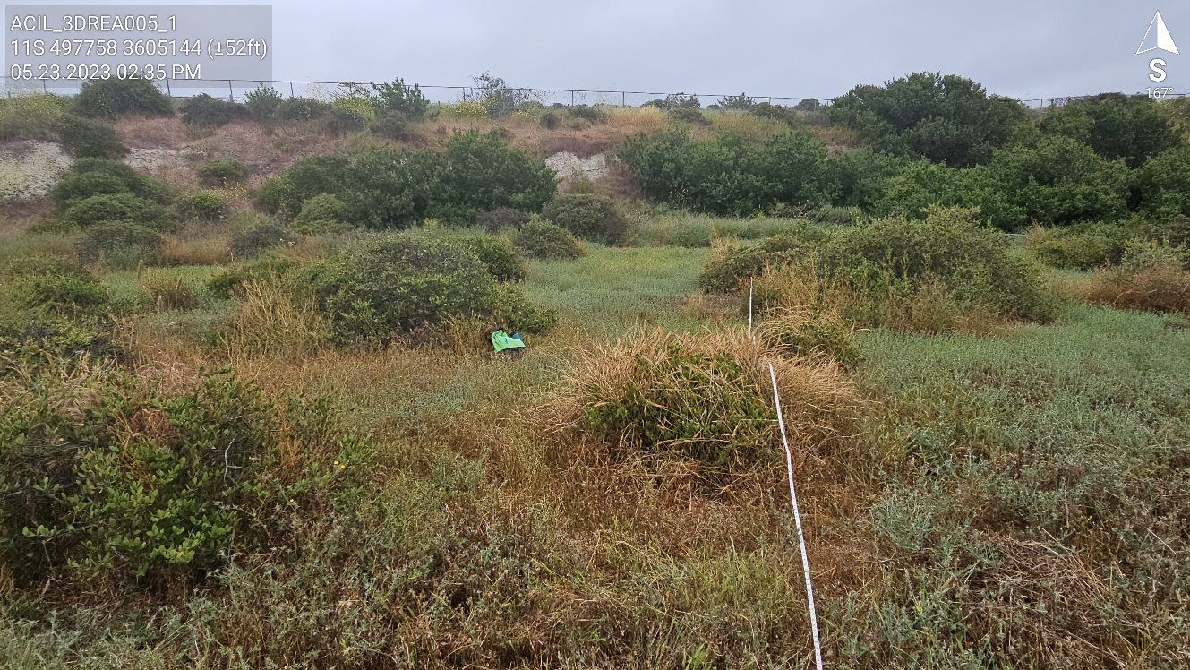
Photo 7: IMG Monitoring Photo for San Diego thornmint (MSP Occurrence ID: ACIL_3DREA005_1)

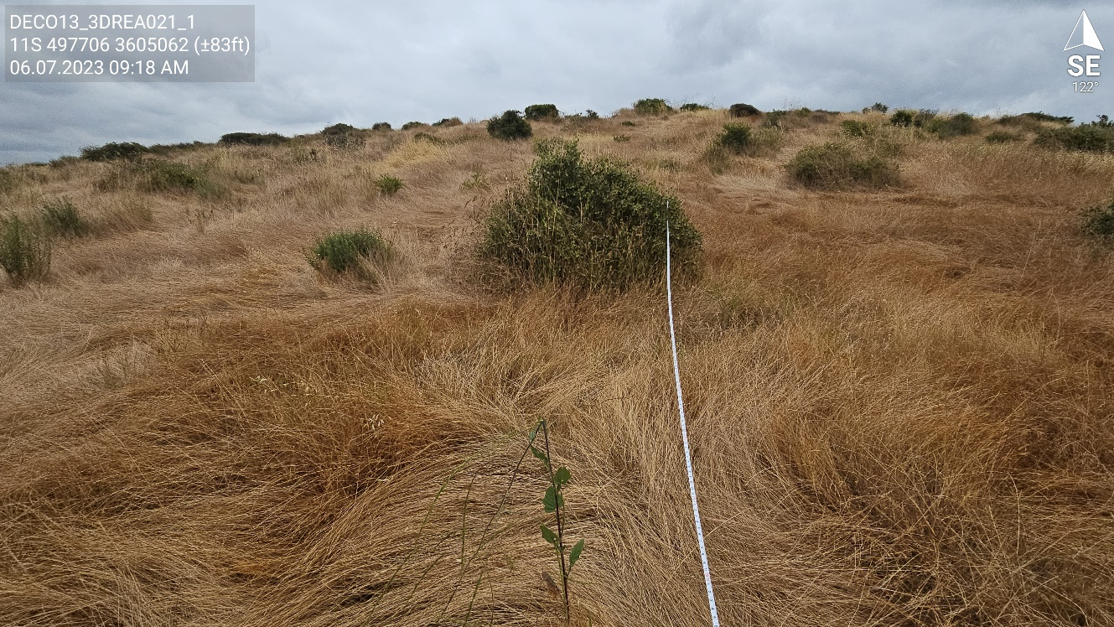
Photo 8: IMG Monitoring Photo for Otay tarplant (MSP Occurrence ID: DECO13_3DREA021_1)

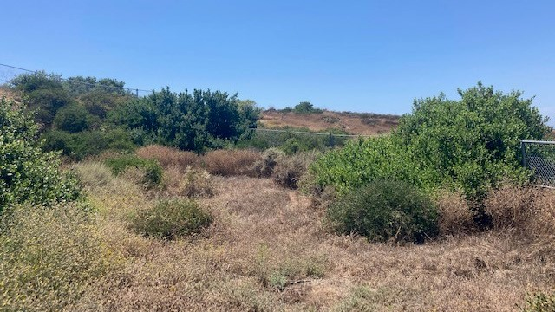
Photo 9: IMG Monitoring Photo for Orcutt’s bird’s-beak (MSP Occurrence ID: COOR7_3DREA007_1)
SDMMP Project Page
This quarterly report was added to the Dennery Canyon Rare Plant Restoration Project Page on the SDMMP website on July 20, 2023.

Performance Measures
Project performance measures are included in the Excel workbook linked below. Click the Excel icon below to open the workbook.

