Projects
Find out about Projects throughout the region
SDMMP’s partners are performing a number of projects throughout the region to promote native habitats and species, monitor the impact of changes in the landscape, and restore natural ecosystems to the preserve system.
The project list is easily accessible from the homepage by clicking View Projects. Users can narrow the list of projects displayed by using the filter options. Project details, protocols, maps, personal, and data is found within each project’s metadata.

A project is defined as a management or monitoring activity that uses a single protocol or method to collect data, analyze data, or physically alter the landscape.
See below for an explanation on project groups.

Use the filter options to find Projects
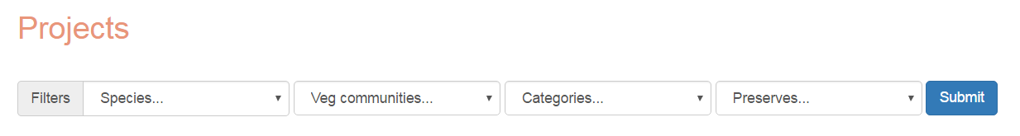
- Use the first two dropdown menus to choose an MSP species or vegetation community.
- Use the Categories dropdown to find projects about a similar topic.
- Use the Preserves dropdown to find projects that are associated with a specific preserve.
- Set one or several filters and click Submit.

Project Groups
Many management and monitoring activities contain several components or tasks that each use different protocols but are unified by a common goal or objective. Because a project is defined as an activity using a single protocol, each of these tasks are added as a separate project. But these projects can be grouped together to indicate that they were done as a single effort.
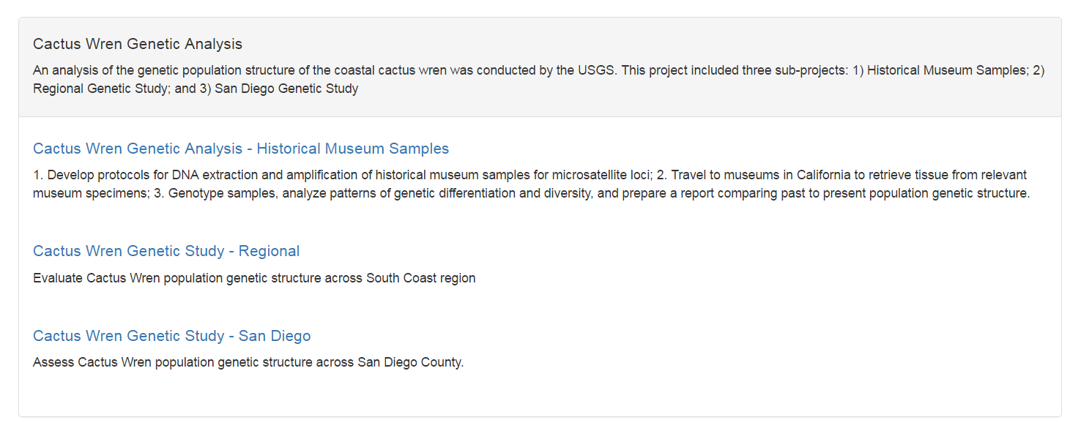
A Project Group is identified with a light grey bar that contains the group title and a description that applies to all the individual projects listed below. The individual project titles are listed in blue and contain a description that is unique to that component.

Find details, documents, and data for Projects
- Click on the Project title from the Project list page.
- Use the diagram on the following page to understand each field in the project’s metadata.

Manage Project Metadata
Registered users can create a new project or edit information on projects, where they have permission. In order to add or edit project information, each user must register for a unique account. Only users given permission to a specific project are able to edit information.

Get started on a new project
- Create an account by clicking on the Log in button on the top navigation bar.

- Click the User account icon to view user-specific information.

- In the Controls panel, click Projects then click Add new projects.
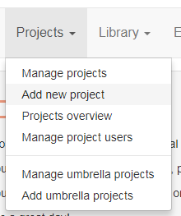
- Fill in the project name and any other optional fields.
- Click Insert.

Note that the project is not publicly available at this point. It must be officially submitted and receive an internal SDMMP review. (See the section, “Submitting a project” for submittal information.)
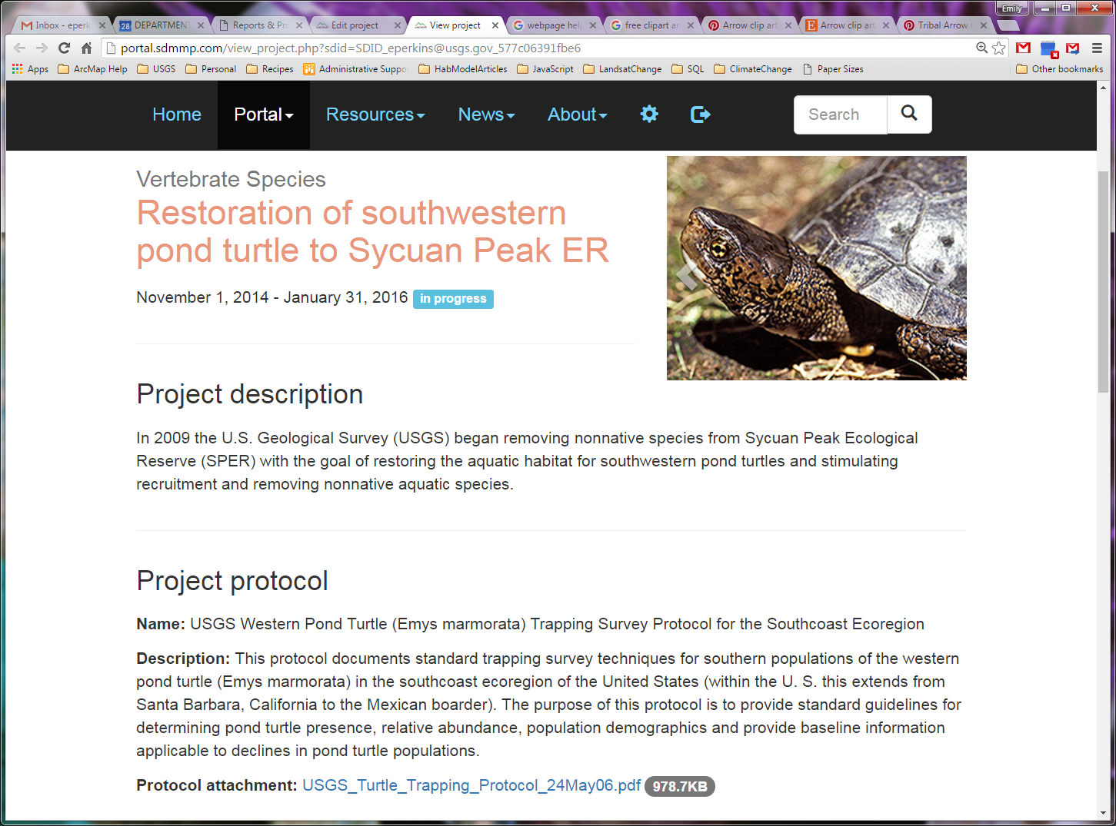
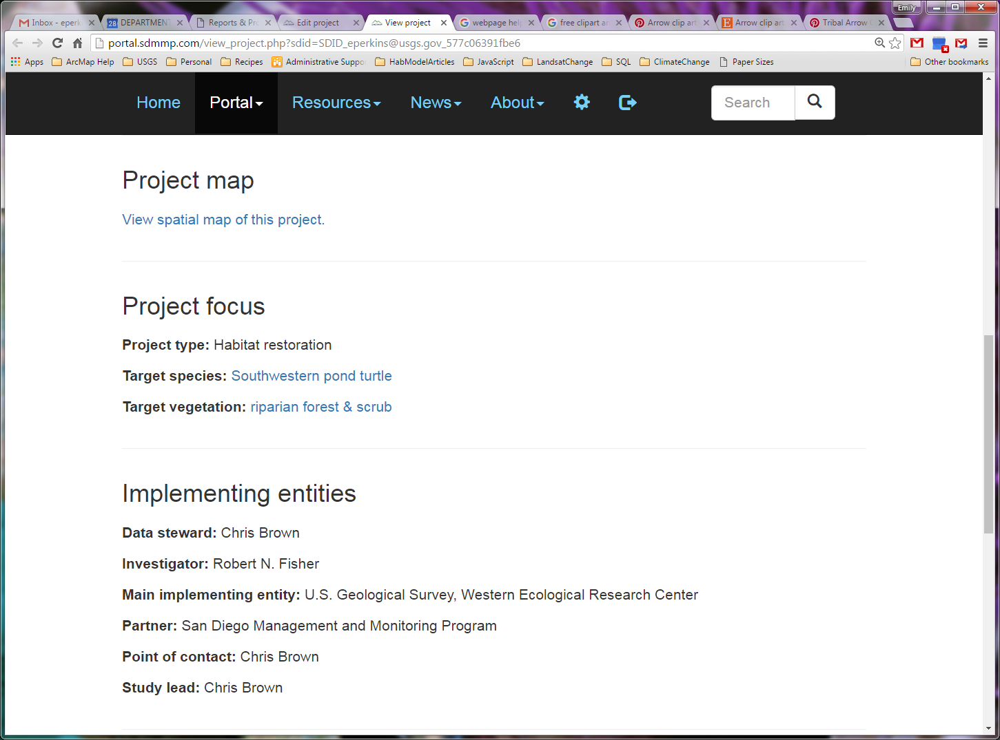
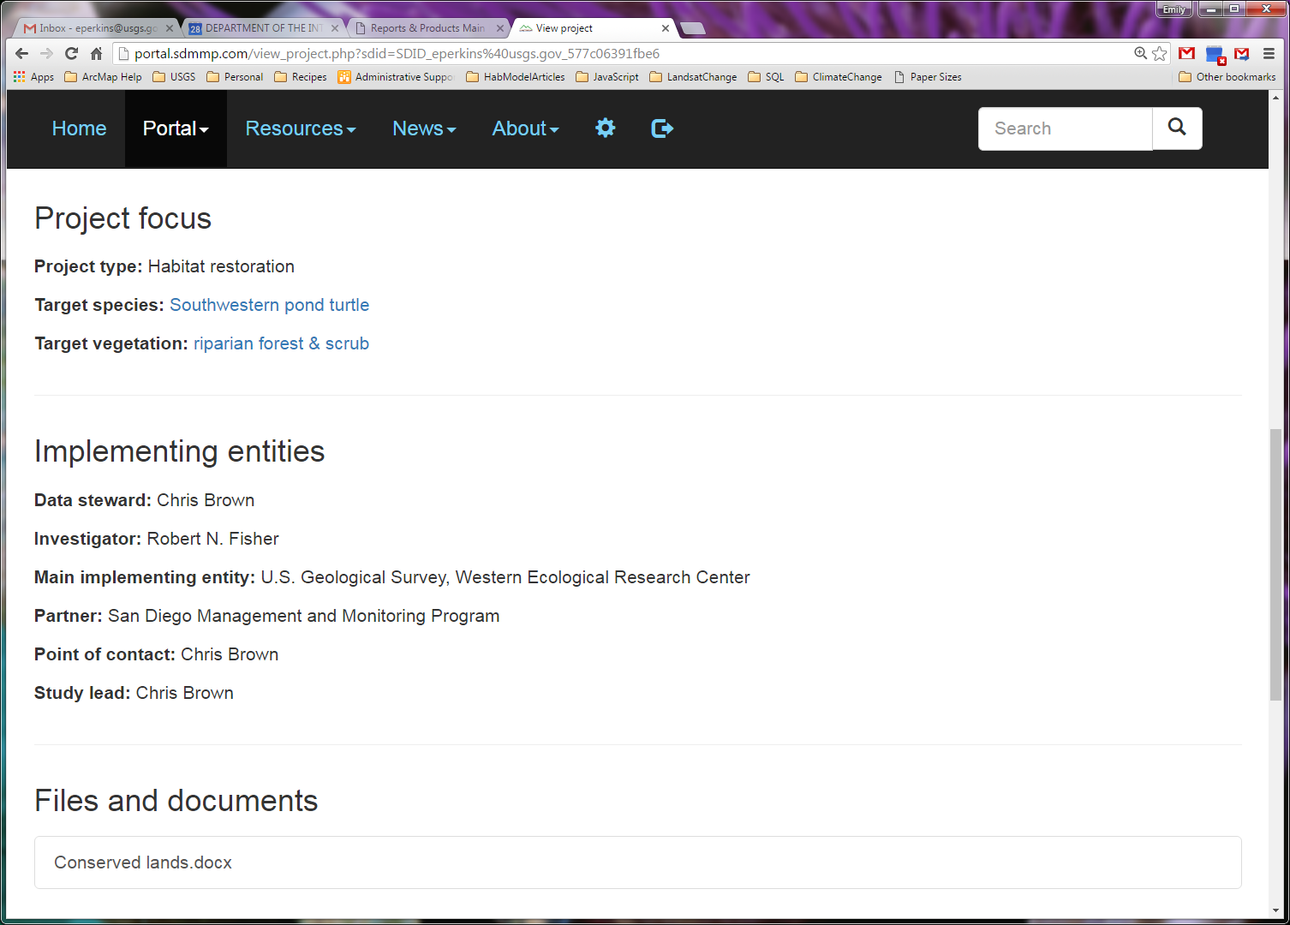
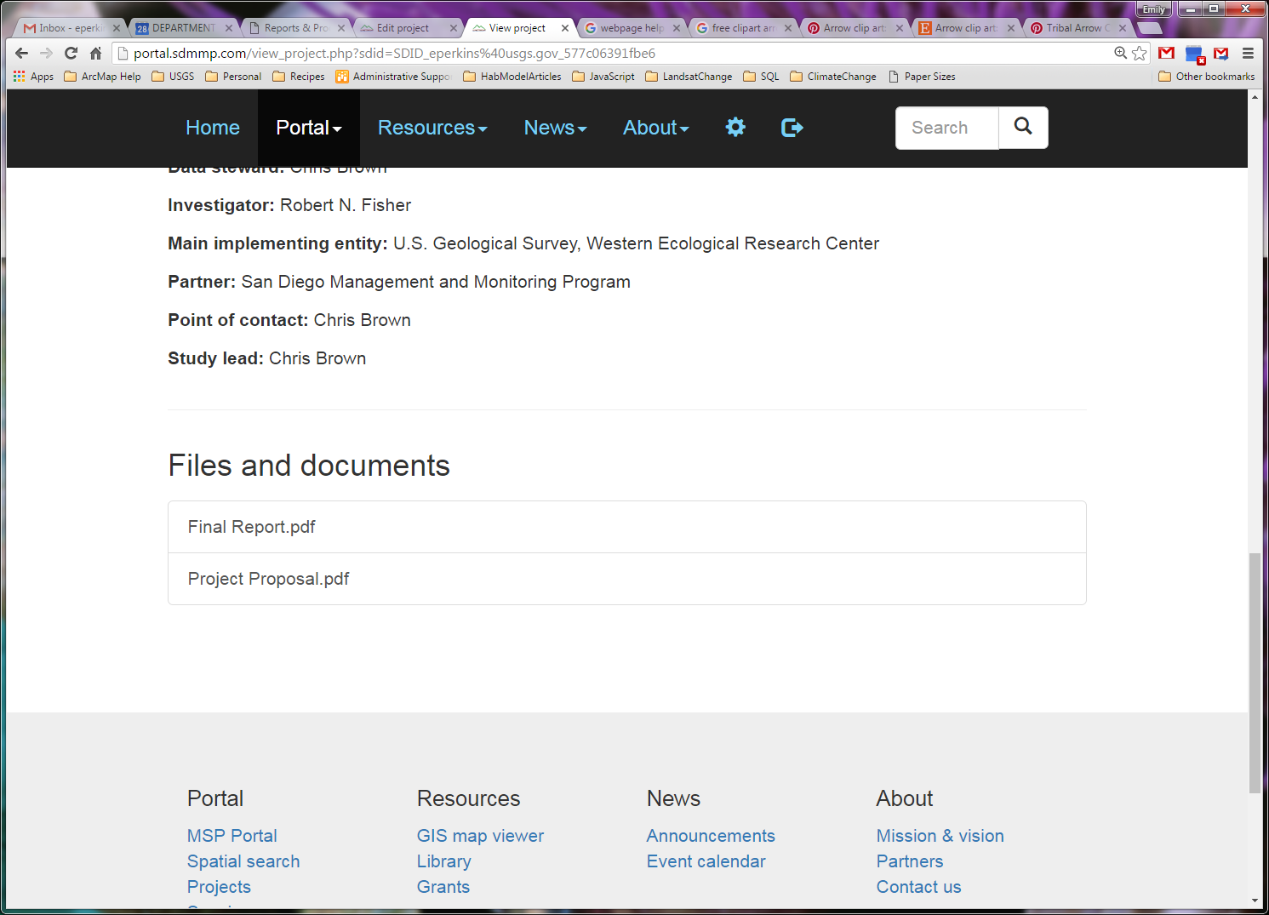
CATEGORY
TITLE
BEGINNING &
END DATE
BRIEF SUMMARY
ROTATING PHOTOS
STATUS
PROTOCOL TITLE
BRIEF PROTOCOL SUMMARY
FULL PROTOCOL DOCUMENTS & SURVEY FORMS
GENERAL EXTENT
TYPE
FOCUS SPECIES
FOCUS
VEGETATION
PERSONNEL
DOWNLOAD REPORT DOCUMENTS

Open a project’s metadata editor
- Once a project is created, the project owner will see it listed in the manage projects section.
- In the Controls panel, click Projects then click Manage Projects.
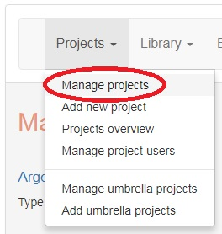
- Click on the Manage project metadata icon, located to the right of the project name. 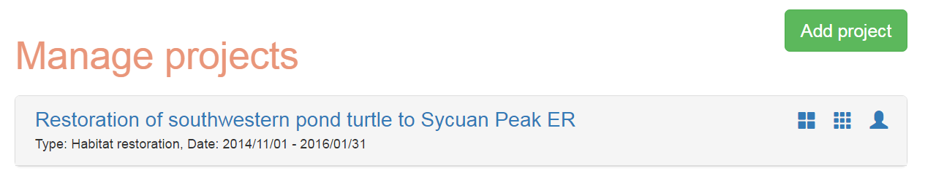

Edit a project’s metadata
- The top section of a project’s metadata includes: Project name, Project type, Project Category, Description, Protocol/methods, Sampling techniques list, Map data URL, Notes, Start dates, End dates, Report dates, Current stage, whether a final report is available. The edit these fields, click the Edit Project Metadata.
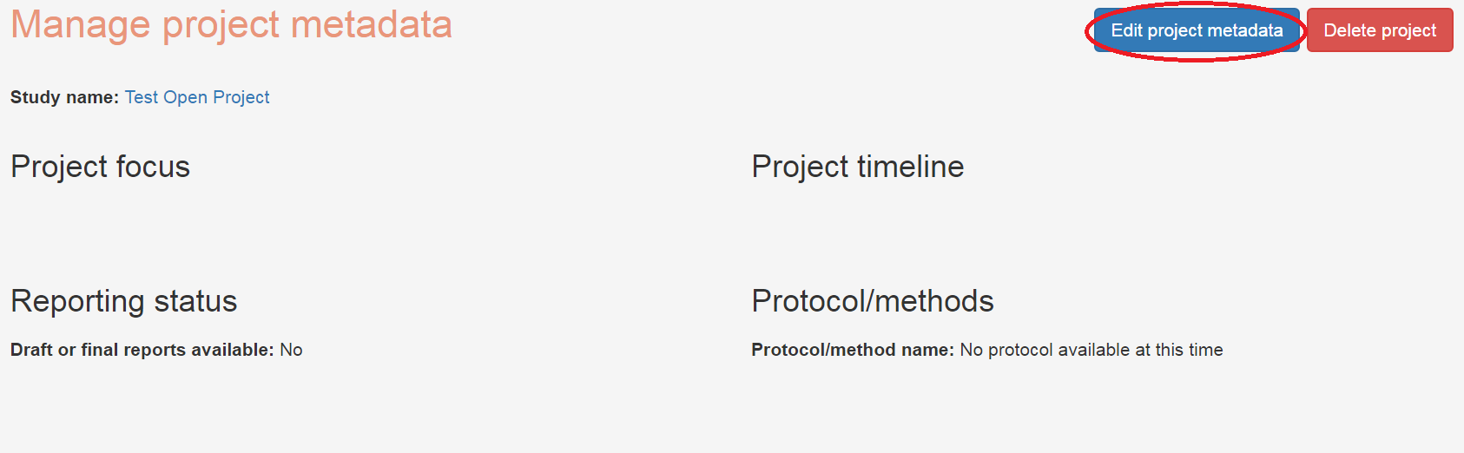
  - Fill out the necessary fields. Once the fields are complete, click Update.
- Related MSP Actions. The next section contains a tool to link the project to the associated MSP Actions.
  - Click Manage Actions. Use the filters at the top to search through the MSP actions. When you have located the correct action, click Add to project.
Note This search tool does not contain information on the objective or goal. It is suggested that you first identify the correct action through the portal tracker search: https://sdmmp.com/tracker.php.
- The next section contains a place to upload documents associated with the project. These can be any type of file. If you are including a spatial layer file, you should zip all the contents together and upload as a single zip file.
  - Click Browse files. Navigate to the correct file. Click Open. Then Click Attach documents (or Attach data files or Attach Photos).
Note Documents, data, and photos contain their own set of metadata and need to be approved by SDMMP before they can be displayed publicly. File names will be displayed in red when they are first uploaded. Click on the name of the document to add document metadata and submit for approval. For documents, this will include adding a title, authors, abstract, and year. Once the document

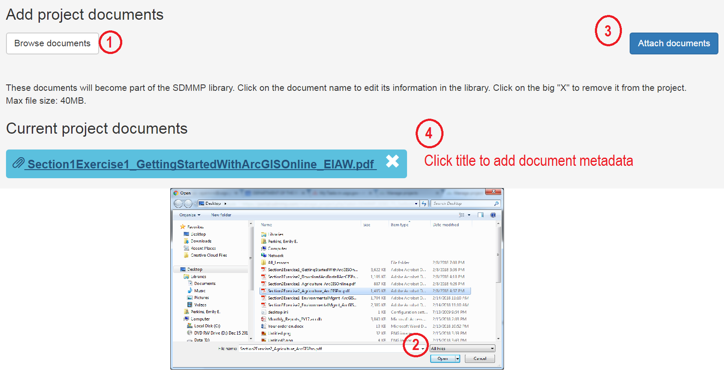
Additional Protocol/Method documents… This section should include survey forms, supplemental information about the protocol, or other documents necessary for understanding the methods of the project. These documents will be searchable through the SDMMP library and require document metadata and approval to display publicly.
Project documents... Documents include PDF reports, contracts, scopes of work, etc. These documents will be searchable through the SDMMP library and require document metadata and approval to display publicly.
Project data files... Data includes field sheets, GIS files, raw data tables, etc. The data files are not accessible through the SDMMP library. Users can only download data files through the project page.
Project photos... Photos appear on the top of the project page. They can contain any aspect of the project that you want to show. Photos are not accessible through the SDMMP library.
- Project Personnel. Enter information about the personnel conducting this project. To enter a name, click in the blank space next to the desired role. Begin typing the person’s name. It will automatically begin searching for the correct name. Select the name from the drop down list.
Note You must enter at least 3 letters to begin searching. In general, 3-4 letters is best. If the person is not listed, click Add new Personnel to add them to the database.
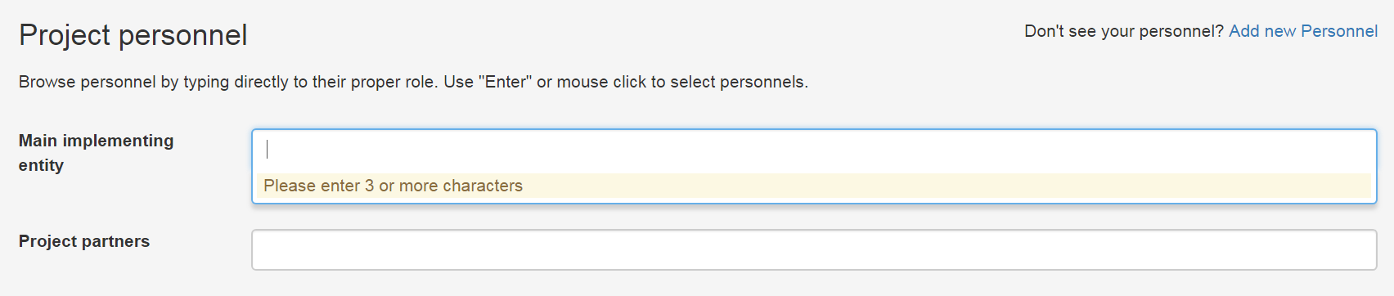
Note You must click Update personnel once all the names have been added in order to update the list.

- Next enter the target species, vegetation communities, and threats. These are all dropdown lists. Choose from the list provided. Be sure to click the update button once all the items are added.
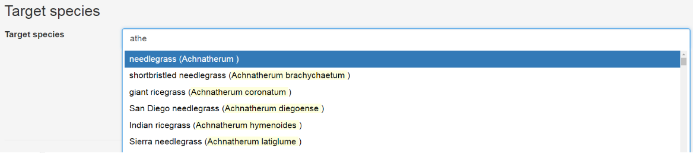
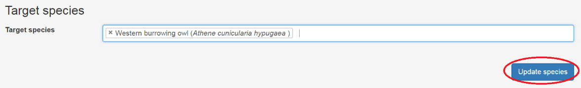
- The final item allows you to list this project within a project group (also called umbrella project). Choose an umbrella project from the dropdown list. Be sure to click Update umbrella projects once it is selected.
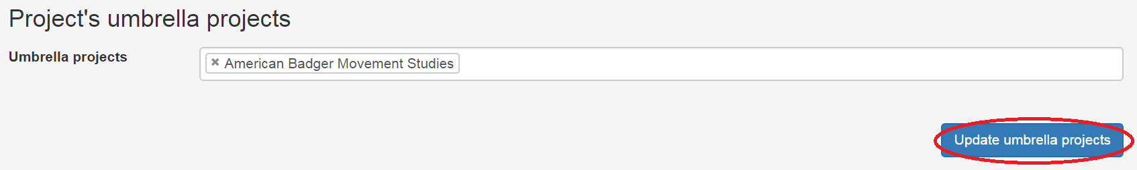

Submitting a project
- When all the relevant metadata fields are filled in and verified by the project creator, the user may select Submit Project, located at the very bottom of the Edit Metadata page.
- You have the ability to submit the entire project to the public, SDMMP partners or selected users. With any option, the title and the description will be displayed publicly on the Project Page.
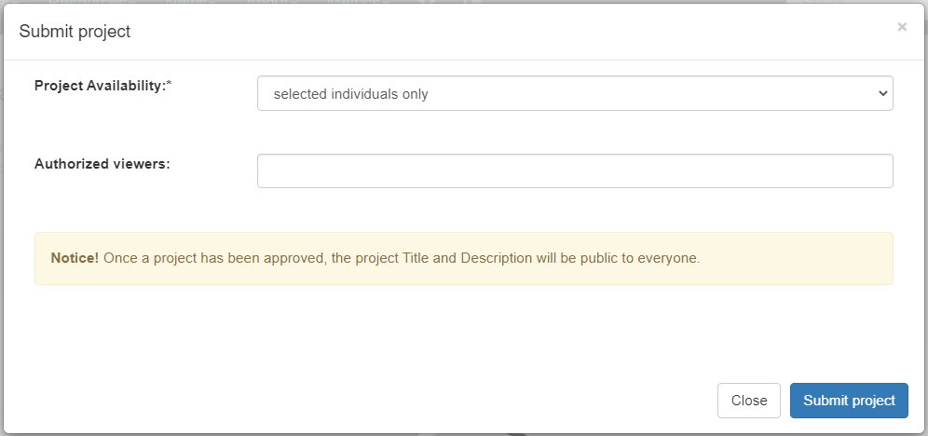
Public… Every component of the project will be available to everyone. Anyone visiting the project pages will NOT need to login and will be able to view all documents and data. Documents will be added to the SDMMP library.
Selected individuals only…. The title and description will be publicly available. All other project components will only be available to users listed in the second box. Users must sign up for an SDMMP account and be approved in order to be added. These users cannot make any changes but can view all the project information
SDMMP partners only…. The title and description will be publicly available. Everyone on SDMMP with an approved login can view all the project components. SDMMP logins are approved when an individual is associated with an agency, company, or non-profit that work with SDMMP.
- Once the Submit Project button is clicked, the SDMMP data steward will be notified to review the project.
- When the project is approved by the SDMMP data steward the project metadata will be available to the selected individuals (see #2 above) and will not be open for further editing. (See the section, “Re-opening a project for edits” for information on making changes after a project has been submitted.)

Adding users to a project
- Log in and view the Manage Projects page.
- When a user is the owner of a project, the manage users icon will be present. Click on the icon to add users and update user permissions.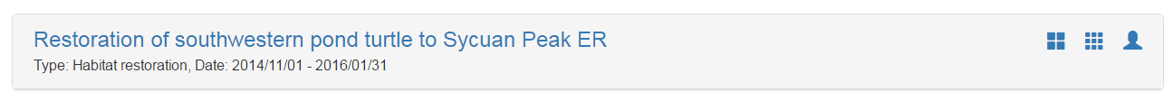
- Under users, click the down arrow to view a list of registered users. Select the desired user from the list.
- Change the yes/no boxes under Owner, Edit metadata, and Edit data to add permissions for the new user. View the list below for a description of each type of permission. 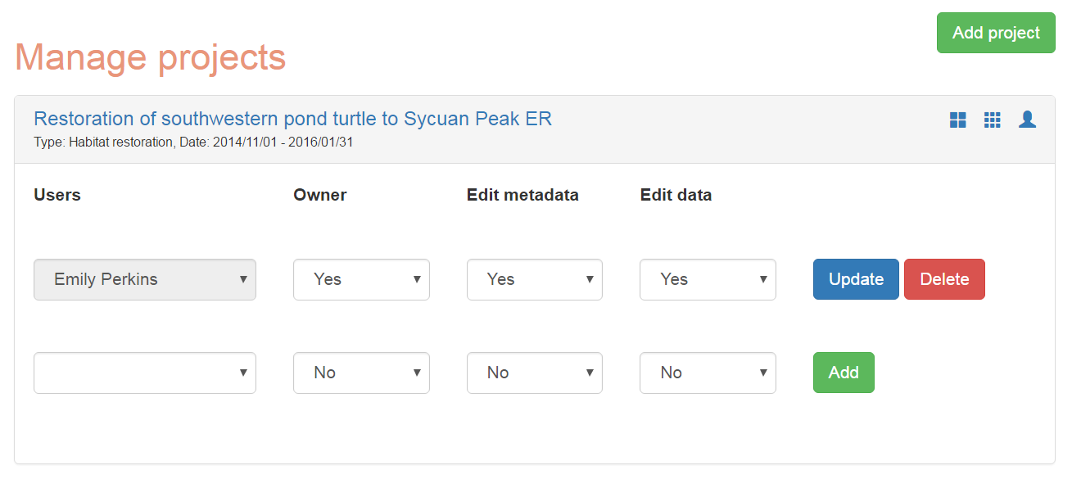
- Once the permissions are set, click Add or Update.
Owner… Any user listed as an owner may add new users and change the permissions of any user.
Edit metadata… Users with Edit Metadata permission may change or add any metadata field.
Edit data… Users with Edit Data permission may change or add project data.

Re-opening a project for edits
Projects that are available to the public cannot be edited without re-opening the project. Once a project is re-opened for edits, it is not available on the public site until it is re-submitted and reviewed.
- For a submitted project, click on the Edit Metadata icon on the Manage Projects page. 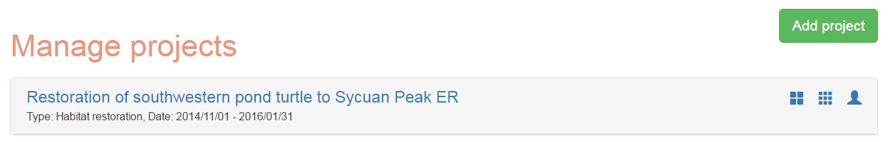
- A message will appear informing the user that this project cannot be edited without requesting permission to re-open the project.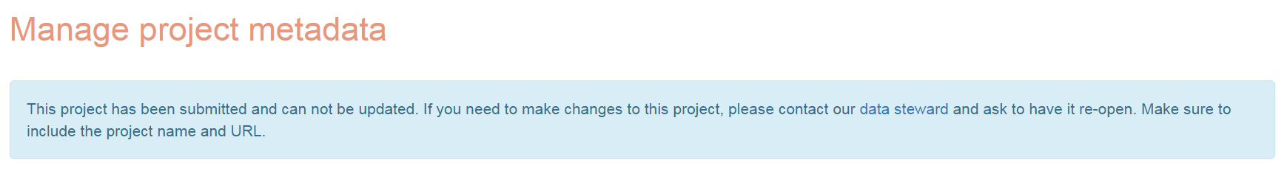
- Click on the words, data steward.
- This link will open an email addressed to the SDMMP data steward. Be sure to include in the email, your username and the exact title of the project that needs to be opened.
- Once sent, the data steward will correspond with the user with further information.

