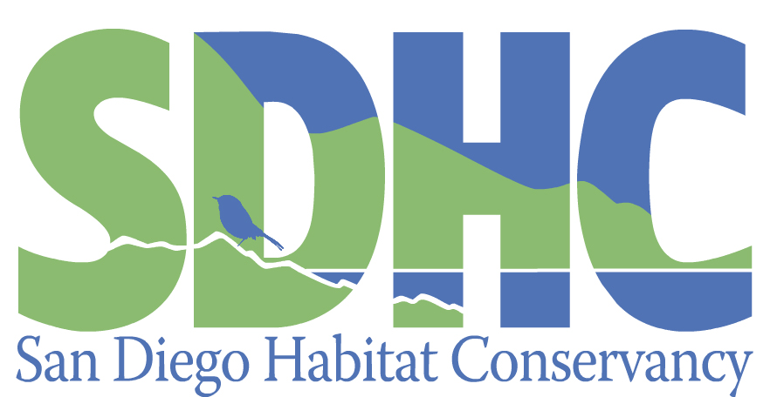

Acquisition Program Manager

The San Diego Habitat Conservancy (SDHC) is looking for candidates for the position of Acquisition Program Manager in our San Diego office. SDHC is a 501(c)3 non-profit, nationally accredited land trust that currently manages over 2,200 acres across 34 open space preserves throughout San Diego County. The Mission of SDHC is to conserve and manage sensitive habitats and species while inspiring land stewardship through education and outreach.
Responsibilities

- Oversee acquisition process of new preserves for SDHC to manage, including review of documents as part of due diligence; drafting documents such as Estimates for Long-term Management, Conservation Easements, Operating Agreements, Access Agreements, and Funding Agreements; and coordinate with clients, SDHC’s counsel, and Executive Director in the finalization of those documents.
- Conduct in-depth due diligence for potential acquisitions.
- Coordinate review of new project acquisitions with SDHC’s Board members and SDHC’s counsel.
- Client management: interface regularly and manage relationships with clients and their consultants to draft and negotiate contracts.
- Assist with other duties when they arise related to project development, project management, Conservancy operations, staff development, client development, and pursuit of grants, as determined by the Executive Director.

The position is full-time salary for 40 hours per week.

Qualifications

- Possession of an undergraduate degree in business, biological sciences, environmental planning, conservation, or a related field. Background and experience should be in a similar field.
- Proficiency with Microsoft Excel and Word.
- Excellent oral and written communication skills.
- Strong organizational skills and self-motivated.

The Acquisitions Program Manager will report to the Executive Director and be relied upon for effective management of the acquisition process for securing new preserves for long-term management.

A willingness to assist the growth of SDHC and support the Mission of SDHC is a must. Salary to be commensurate with experience and ability. Employee benefits include paid time off, flexible work location, holidays, health insurance, and Simple IRA with match. For more information about SDHC, visit our website at www.sdhabitat.org.

Interested candidates should submit a resume and cover letter to Don Scoles, Executive Director, at dons@sdhabitat.org by March 1, 2024.

