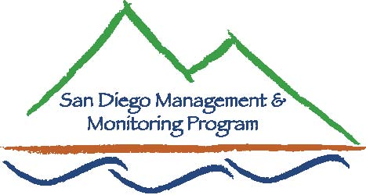

SDMMP Monitoring & Management Coordination Meeting
January 25, 2017, 9:30 am – 11:30 am
USGS Conference Room, 4165 Spruance Rd, San Diego, CA 92101
Contact Info: Yvonne C. Moore, Administrator (evemoore99@gmail.com); Kris Preston, Ecologist (kpreston@usgs.gov); Emily Perkins, GIS Manager (eperkins@usgs.gov); Trish Smith, Coordination Support (trish_smith@tnc.org), Sarah McCutcheon, Coordination Support (Sarah.McCutcheon@aecom.com), Brenda McMillan, Outreach Cordinator (Brenda.McMillan@aecom.com), Annabelle Bernabe, Data Entry/GIS Assistant (aebernabe@gmail.com)

Agenda

- Introductions (9:30 - 9:35am)

- Announcements (9:35 – 9:50am)
  - SDMMP Updates
  - Others Updates

- Speakers (9:50 – 11:00am)
  - The Herpetofauna of El Monte Valley – Johnathon Richmond, USGS Geneticist

- Roundtable Discussion (11:00 – 11:25am)

- Closing Remarks and Future Meeting Topics (11:25-11:30am)

Feb 22 Direct and Indirect Effects of Precipitation, Nitrogen and Management on a Rare Coastal Sage Scrub Species: Acanthomintha ilicifolia
Mar TBA
Apr TBA
May TBA

Possible future topics:
Carbon Sequestration science and vegetation management practices at the local level - TBD
Defining mitigation reference conditions in urban settings – Great Ecology
SR67 Deer Genetics Project – Amy Vandergast, USGS
San Elijo Lagoon Conservancy Update – Doug Gibson, Exec. Director and Principal Scientist San Elijo Lagoon Conservancy
City of Carlsbad/Pilot Ranger program - Roseanne Humphrey

Our next monthly monitoring meeting will be held 9:30 a.m. – 11:30 a.m. on Wednesday,
February 22, 2017 at USGS

